**TOPIC I HAVE COVER IN sql :  
-> INDEXING   
-> TYPES OF INDEXING   
->REVISION OF JOIN AND SELF JOIN   
-> RENK  
->DESRANK  
->CLUSTERING   
->WINDOWS FUNCTION  
->STORE PROSEDURE  
->FUNCTIONS.  
  
Basic Postgres SQL :** is a db we use to store the information and retrieve the information.  
  
Execution from of any query in SQL:  
 1.FROM: The first step is to identify the tables involved in the query.

2.JOIN: If there are any joins, they are processed next.

3.WHERE: The filtering of rows based on the conditions specified.

4.GROUP BY: The rows are grouped based on the specified columns.

5.HAVING: Filters groups based on the conditions specified.

6.SELECT: The columns to be returned are selected.

7.DISTINCT: Removes duplicate rows from the result set.

8. ORDER BY: The result set is sorted based on the specified columns.  
9. LIMIT/OFFSET: Limits the number of rows returned / specifies the starting point.

LIMIT: Limits the number of rows returned and specifies the starting point.  
OFFSET: how many rows have to skip.  
  
Note: There will be many ways to write a query for one solution.  
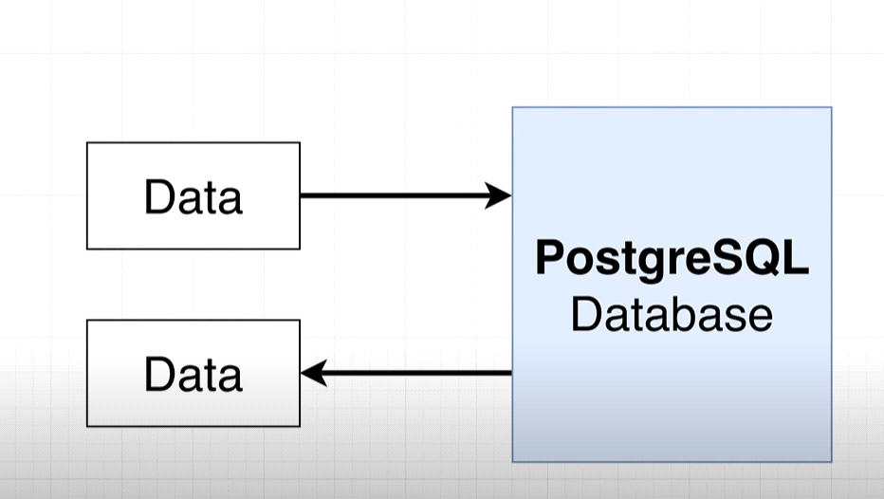

**# To work with postgres we connect to client,** client can we utility server or a program which access and store the data with some purpose. 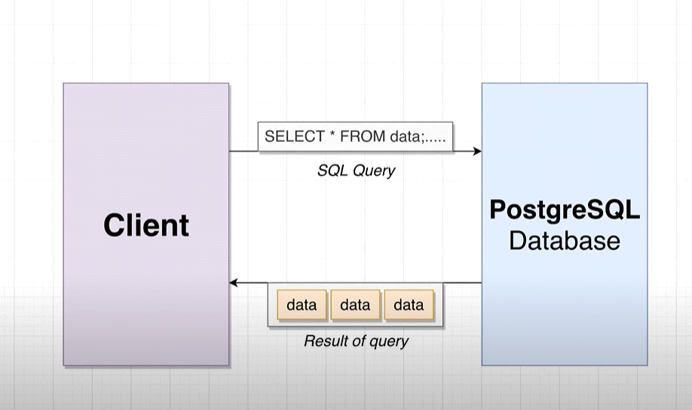 **# we connect client to db using SQL(STRUCTURED QUERY LANG):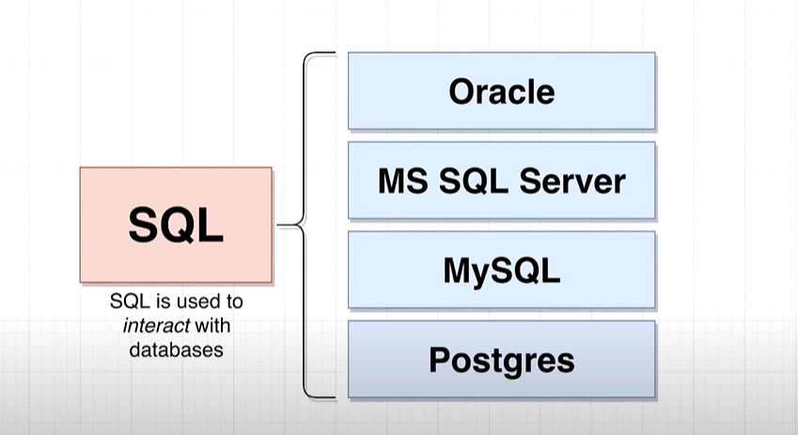 Note :** we use SET in postgres to update the data into db.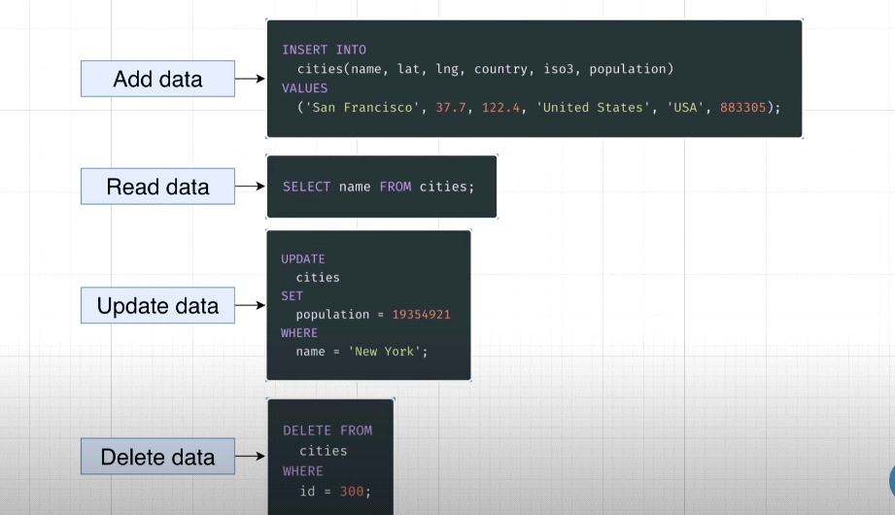  
# when u write the query think following point 1st for facing challenges:  
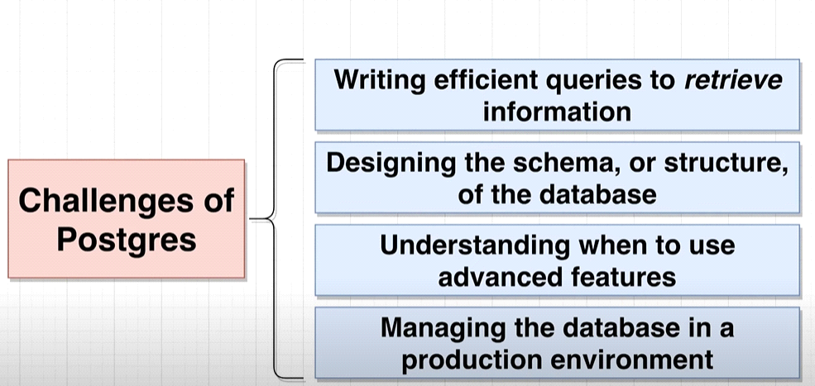  
Here we will focus on 2 challenges :

* Writing efficient query.
* Designing the structure of the db.

**# Before designing the db we follow the following process: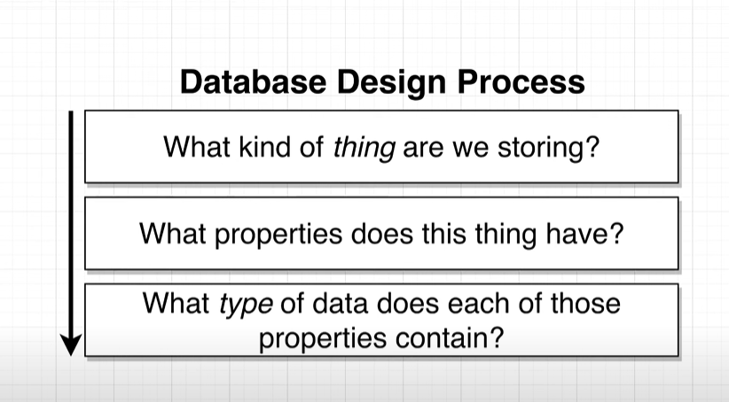 assume here we are taking example of populated city in the world: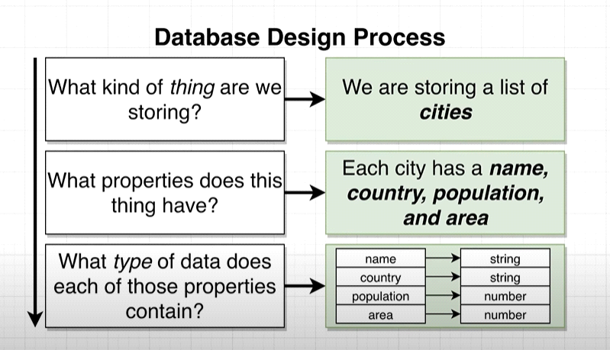 Than we should think in this way: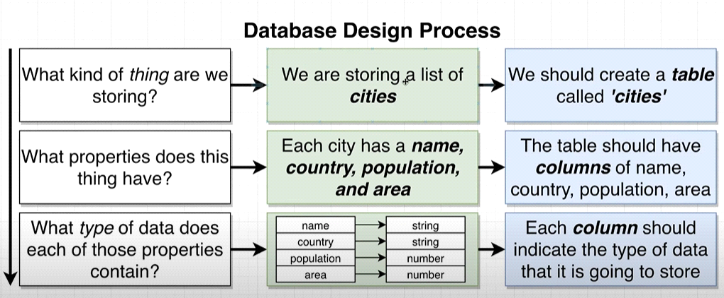 than we create a table like following: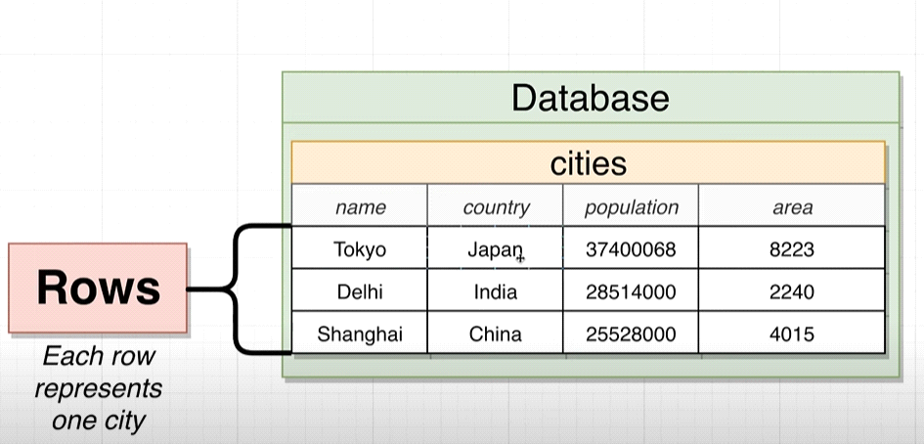 Now, we will write the query to create a table:**   
CREATE TABLE cities(  
name VARCHAR(50),

Country VARCHAR(50),

Population INTEGER,

Area INTEGER  
); **After running this query following structre will going to create in ur db:**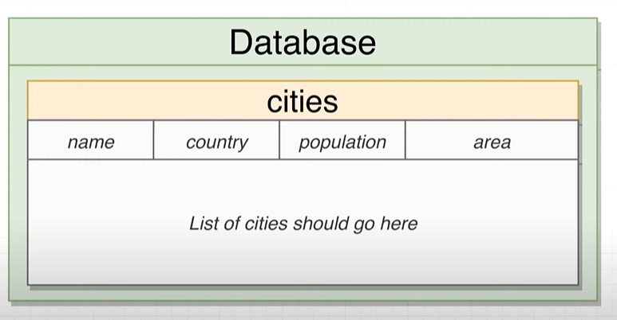

**Note: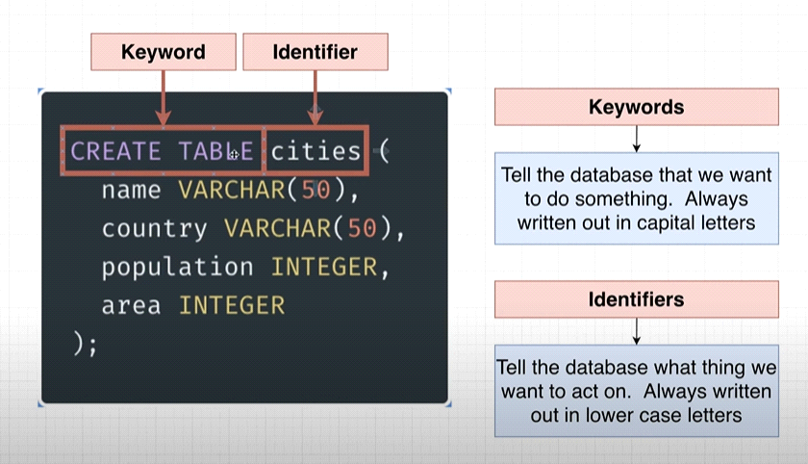 Now will insert the value into the table:**INSERT INTO cities (name,Country,Population,Area)

VALUES ('begaluru','india',45783783,6876);

Inset multiple rows in single column:

INSERT INTO cities (name,Country,Population,Area)

VALUES ('begaluru','india',45783783,6876),

('tokyo','japan' ,773783,676),

('shanghai','china',6783783,66876),

('Soa_Paul','Brazil',5483783,23876);

To directly fetch the data from the table we can use :  
 SELECT * FROM cities;

If u want specific column than :

SELECT name , Country FROM cities;

# Except pulling data we can perform operation and transform the data before we retrieve, for example I want the density of the city per square km so:

Density= population/area

SELECT name , Population/Area AS Density FROM cities;

# Same like that we can filter the query result :  
 SELECT name , Country FROM cities where area>4000;  
 it execute in following way:  
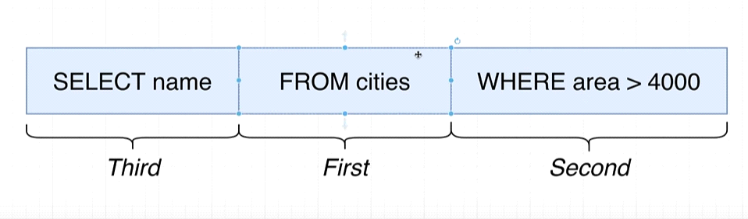  
Some operator we use with where:

SELECT name , Country FROM cities where area>700;

SELECT name , Country FROM cities where area BETWEEN 100 and 4000;

SELECT name , Country FROM cities where area IN (600,66876,6876);

SELECT name , Country FROM cities where area NOT IN (600,66876,6876);

Note: In between oprerator it included the value as well to check.

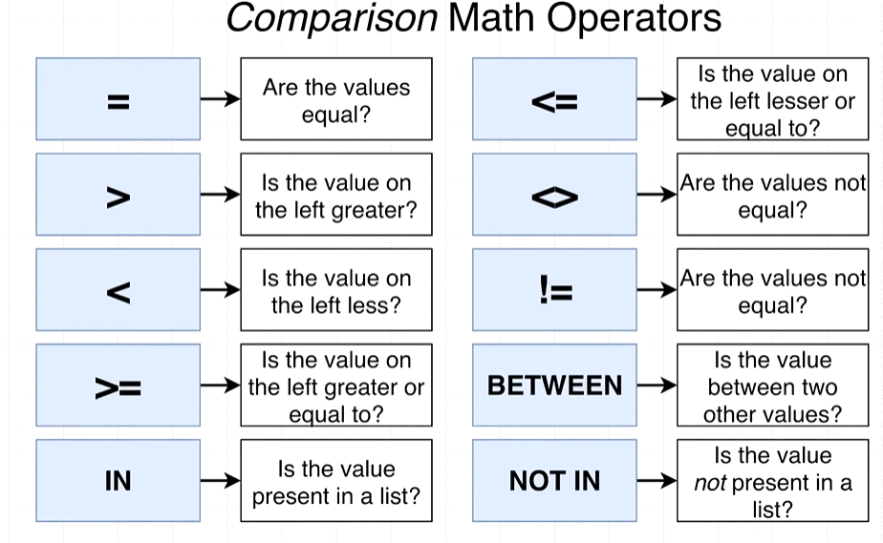

Note: If u try with following way it will give u a error:  
 SELECT name , Population/Area AS density FROM cities WHERE density>6000; because

density is not a column in the table.

SELECT name , Population/Area AS density FROM cities WHERE Population/Area >6000;

Is a correct way.

#**Now we will use the update to update the existing data into the table:  
 UPDATE cities**

**SET Population = 39550500**

**WHERE name = 'Tokyo';**

**Delete keyword:  
 DELETE** FROM **cities WHERE name =’tokyo’;**

IN Reality we have many table in one db like following :  
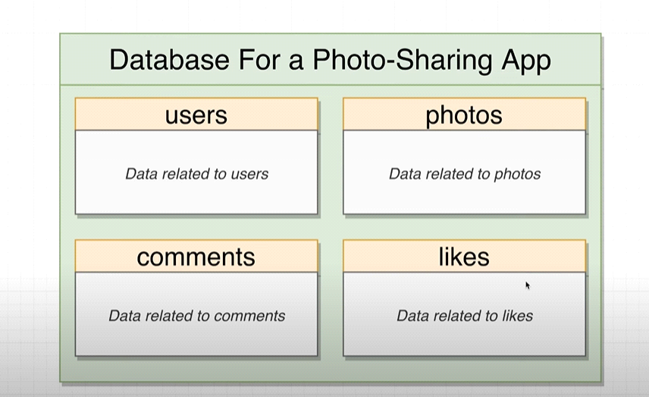  
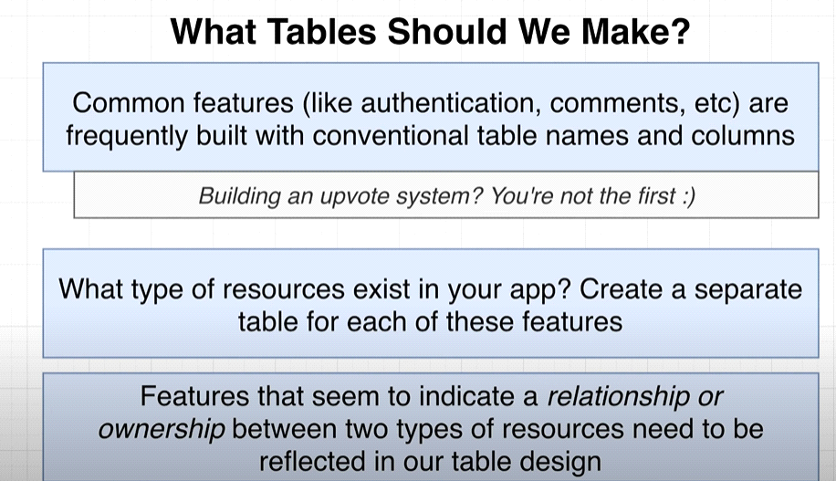  
Lets take a example of insta where we have many sections, this is the user profile page :  
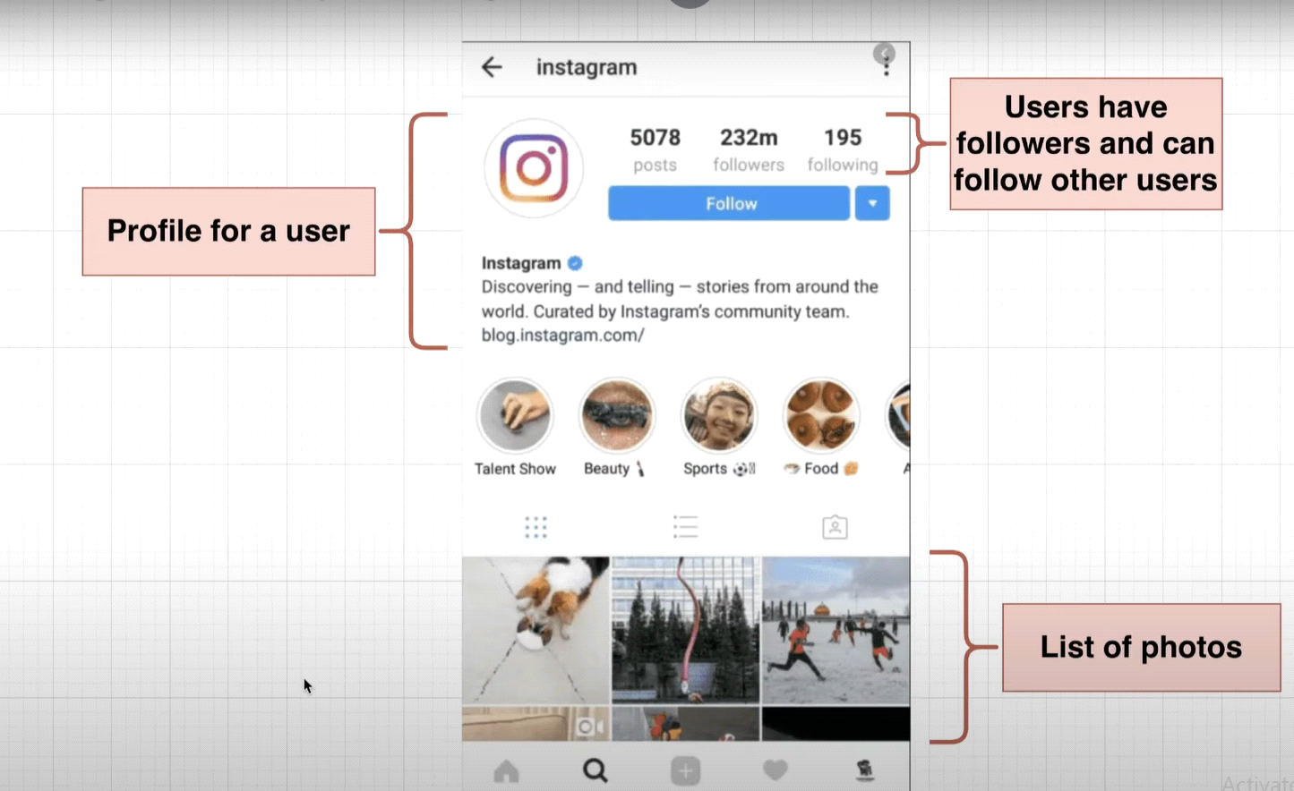  
Here in comman page we have some post on it:  
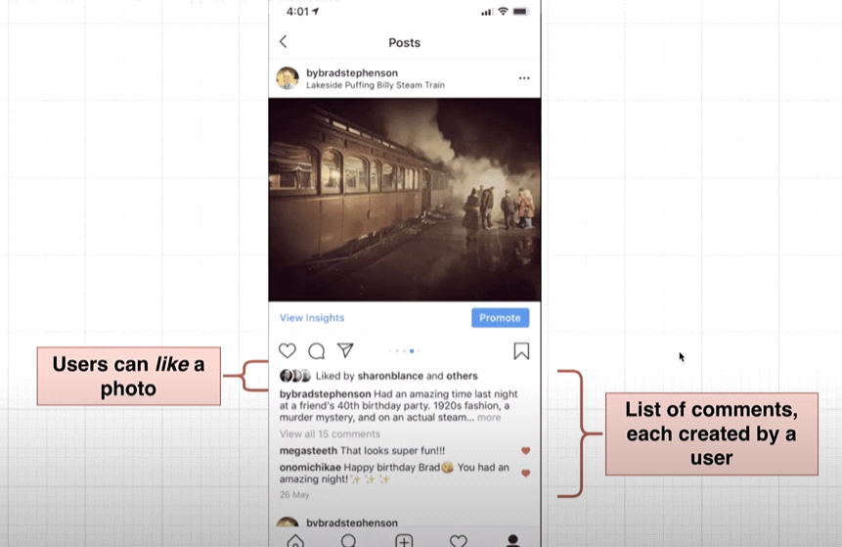  
**From there we can understand there is a relationship between users and there comments:  
In RDBM we have 4 type of relationship:  
 1. 1:1 (one to one)  
 2. 1:M(one to many )**

**3.M:M (many to many).  
4.M:1 (many to one)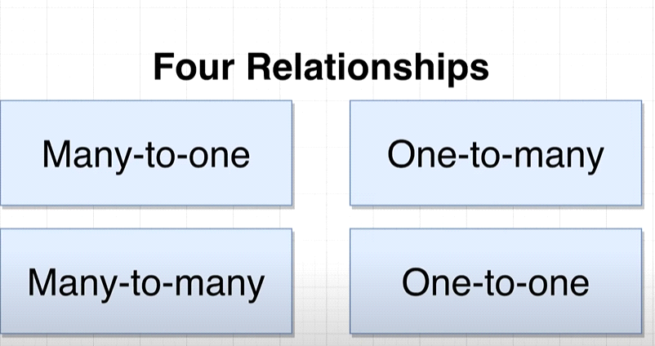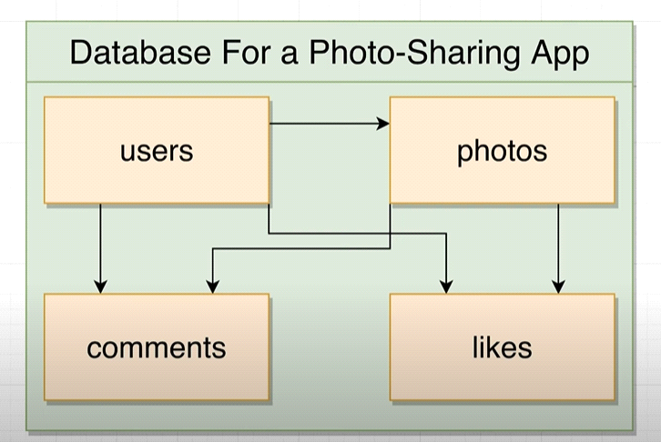 One to one relationship(1:1):**

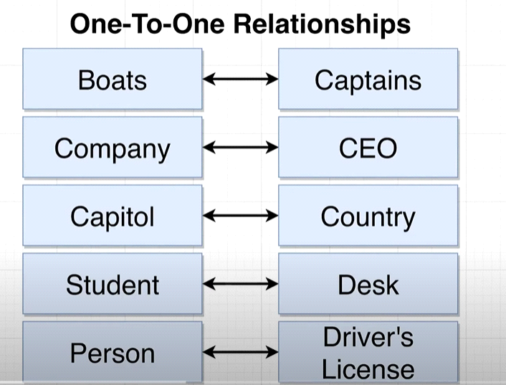 **One to many relationship 1:M: has one**one insta user can post mant photos.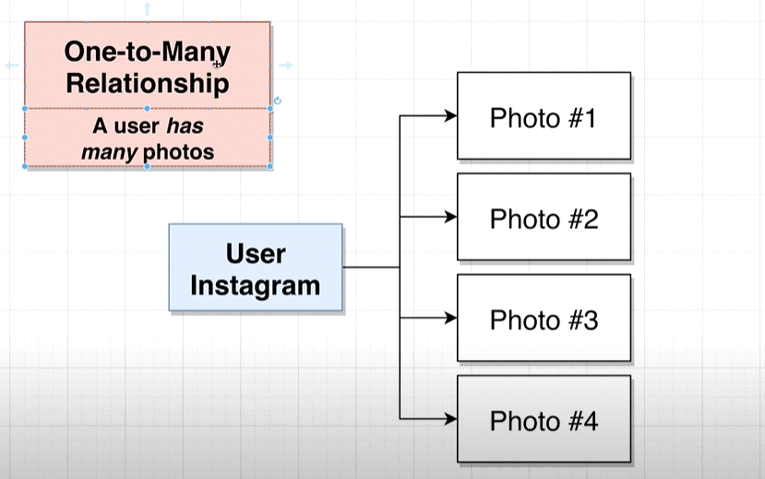  
**Many to one (M:1): Has Many**one photo has many comment.  
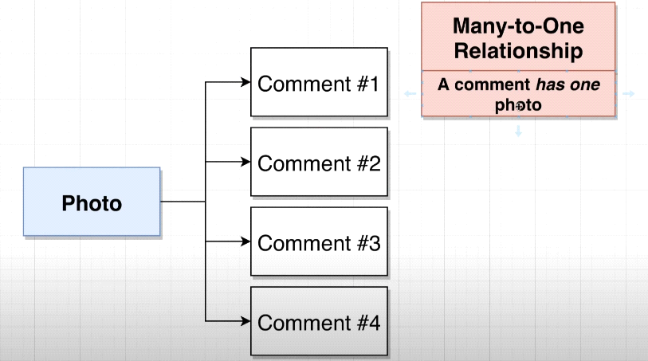  
 Note: One to many and many to one both are vise versa only perspective we have to change.  
 1:M <-> M:1  
  
# Many to many relationship M:M:  
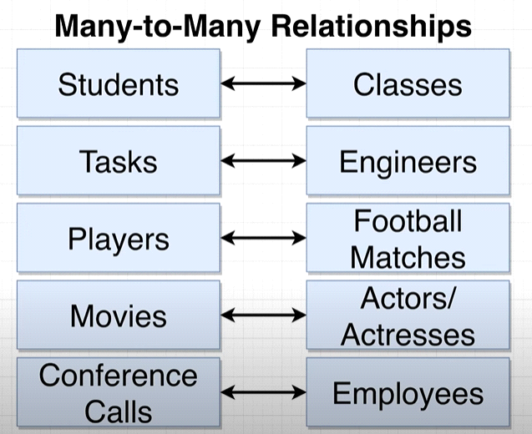  
Note: To set the relationship between table we have following keys:  
1.Primary keys(Unique row and not null)  
2. Foreign key (foreign key can be null)  
we relate the relationship between foreignkey and primany key of another table.  
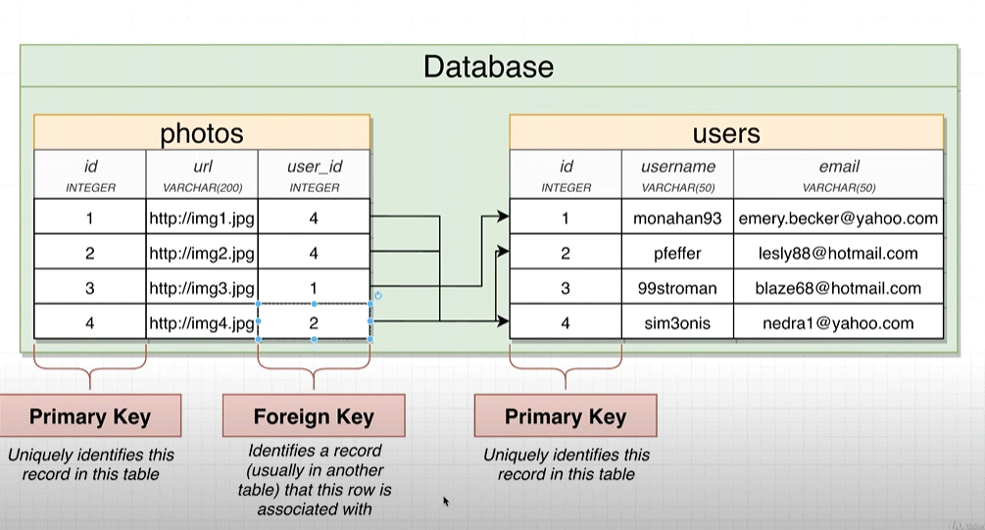

# Note:many side of the table get the foreign key table :  
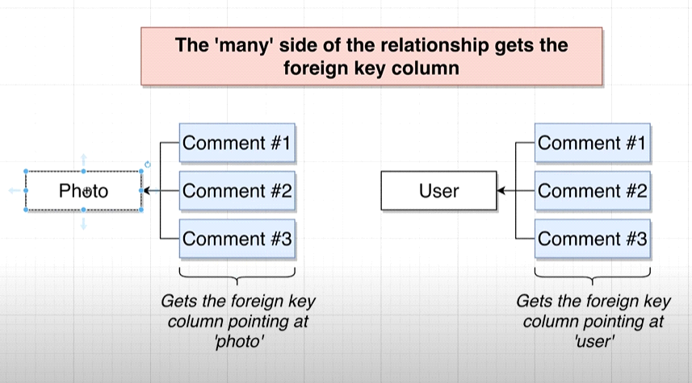  
Example:

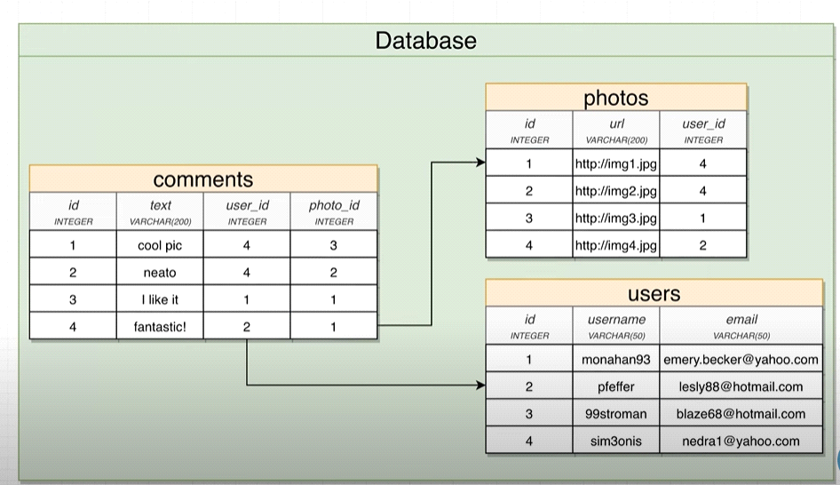  
Note: difference between foreign and primary key:  
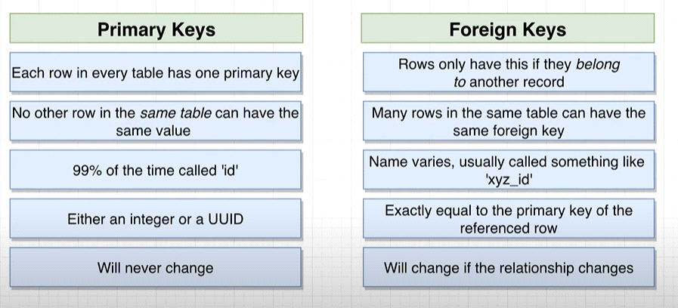

Let’s write the query for user table:

CREATE TABLE users(

Id SERIAL PRIMARY KEY NOT NULL,

Username VARCHAR(50)

);  
Note: SERIAL will automatically increase a id column value by 1, it’s Postgres functionality.  
  
Now Let’s insert some value into the table:  
Note :here we are not passing the id because SERIAL will automatically handle.

INSERT INTO users (username)

VALUES('Ravi'),('james'),('abdul'),('sidhu');

# Lets create a photos table :

CREATE TABLE photos(

Id SERIAL PRIMARY KEY,

url VARCHAR(200),

user_id INTEGER REFERENCES users (id) --this create the foriegn key

);

Than insert some data into photos table:

INSERT INTO photos (url , user_id)

VALUES('hhtkjhsjhjkj',4),

('hhtkjhsjhjkj',4),

('hhtkjhsjhjkj',1),

('hhtkjhsjhjkj',2); **____________________________  
Note: Consistency in DBMS:-**

Data integrity and reliability are key in the domain of Database Management Systems (DBMS). Consistency, one of the core principles in DBMS, ensures that every transaction is made according to predefined rules and limits thus preserving the accuracy and authenticity of data kept within. The change to the database must take it from one consistent state into another.

Consistency, in DBMS, requires that any modification to a single piece of data be reflected uniformly across all linked tables as well as entities. For example, suppose you have a driver’s license database. Updating a driver’s house address should consistently appear in all relevant tables just to avoid mismatching data.

It is not enough for consistency in DBMS since it may not result in transactional correctness at all times but it plays an important role in shielding against programming errors that violate set up database constraints. To make sure that data remains reliable and intact, RDBMS go through the process of enforcing consistency to create a firm foundation for robust and trusted applications based on stored data.

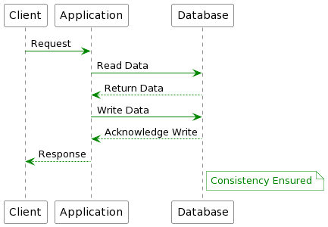

*Consistency in DBMS*

**Why is Data Consistency in DBMS Important?**

In a database, maintaining accuracy and usability are vital to ensuring consistency. Mismatching data can destabilize or corrupt systems, thus undermining the integrity of the database. For that reason, all users must input data in a way that is consistent with current database records; this is normally accomplished by isolating data fields to avoid conflicting transactions.

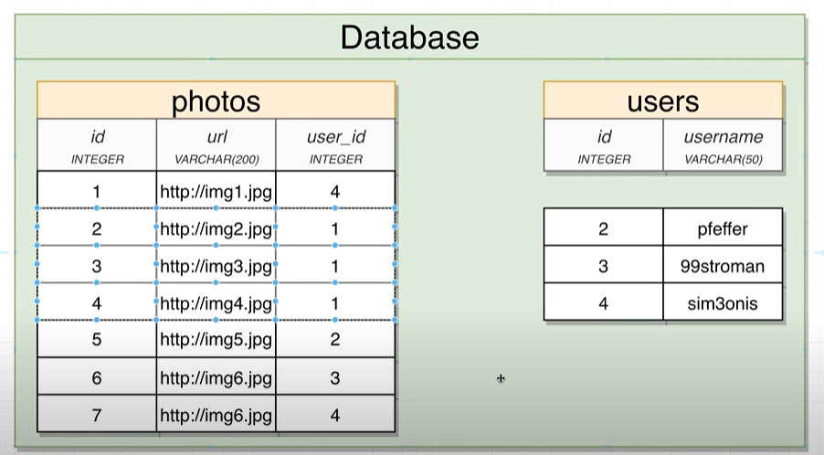

But now problem here is if user got delete (or user has deleted his profile picture from insta than what about the uploaded picture and all information) in this case remaining garbage data will increase so we follow the following solution:  
  
  
  
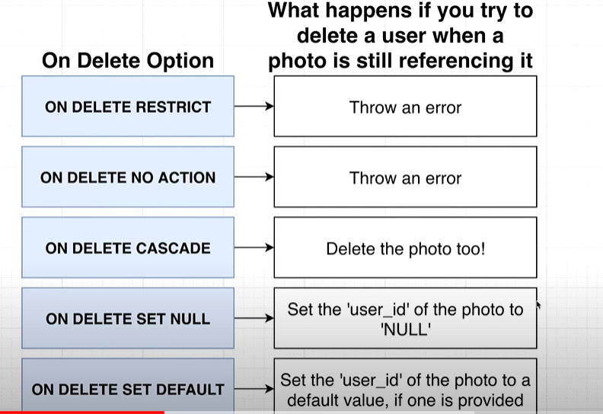  
  
Note:

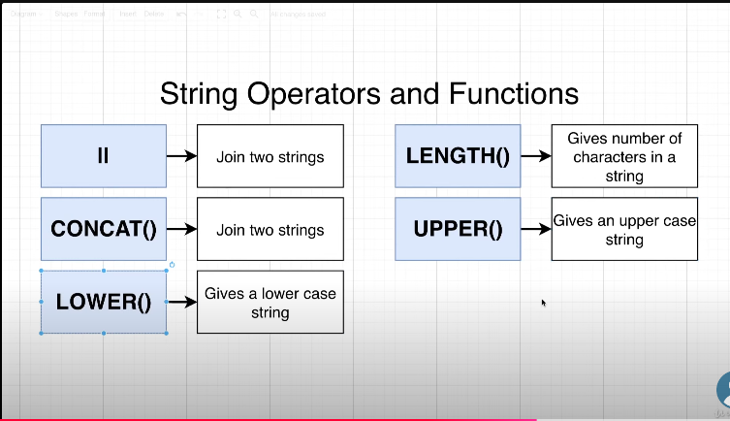  
  
**UPDATE** => we use "SET" in postgresSQL to update the value into database.  
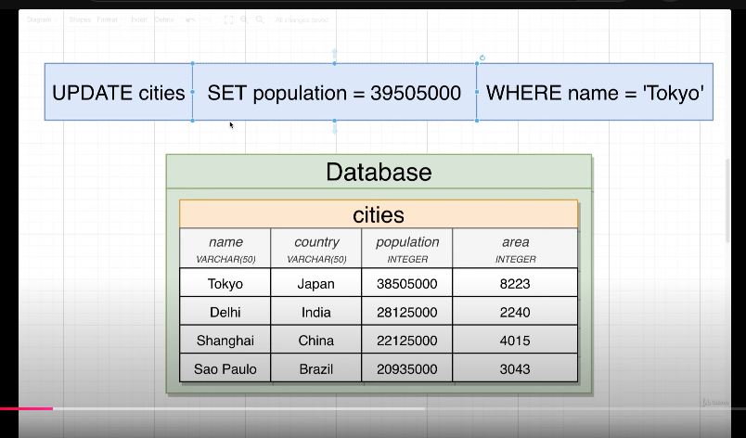  
  
DELETE =>   
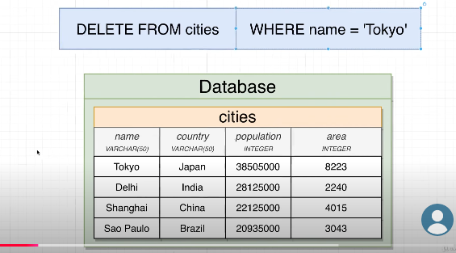  
Note : <> this symbol also mean by not equal to.  
  
Q : **designing the dbfor photo sharing application:**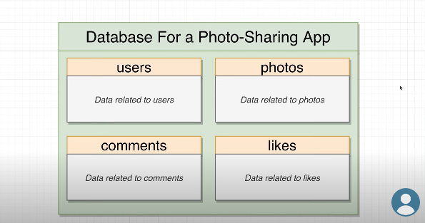

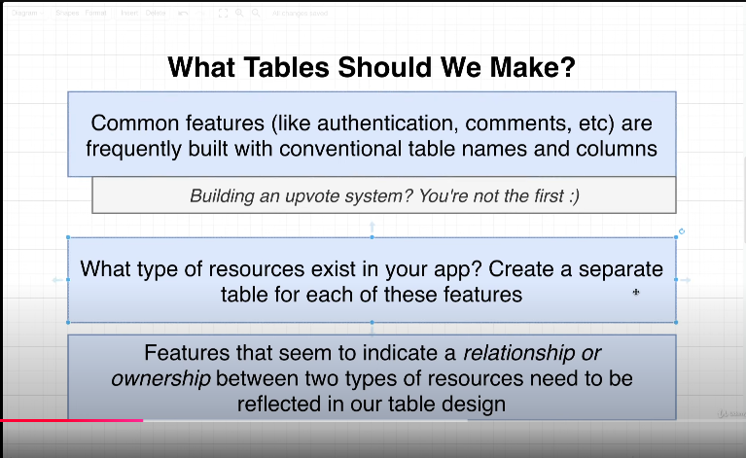

So currently my DB looks like this :  
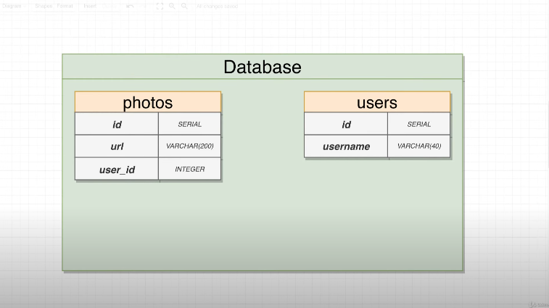  
  
=> Now I will add the comments table inside the db and make a relationship inbeetween:  
=> below way we can make a relationship between 2 table :  
  
=> Assume you want to create a table with relationship with another table:  
  
CREATE TABLE Orders (

OrderID SERIAL PRIMARY KEY,

OrderDate DATE NOT NULL,

CustomerID INT NOT NULL,

FOREIGN KEY (CustomerID) REFERENCES Customers(CustomerID)

);  
  
If table is already created, in this case:  
  
ALTER TABLE commentss

ADD CONSTRAINT fk_user_id

FOREIGN KEY (user_id) REFERENCES users(id);  
  
=>ALTER TABLE commentss  
ADD CONSTRAINT fk_photo_id  
FOREIGN KEY (photo_id) REFERENCES photos(id)  
  
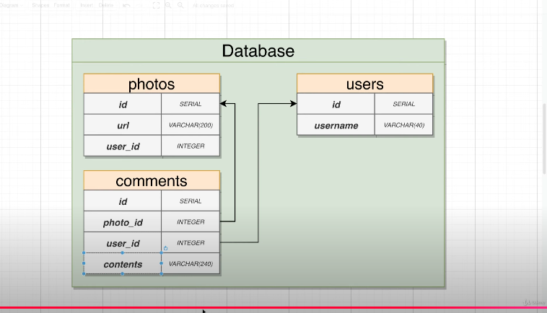

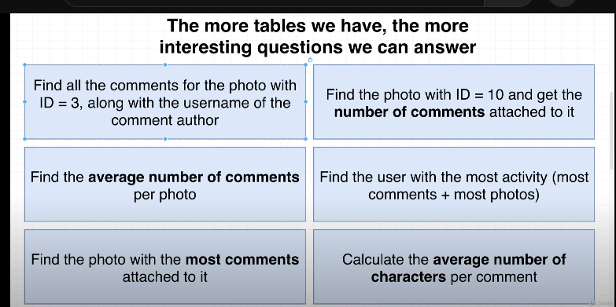

"JOINS:"  
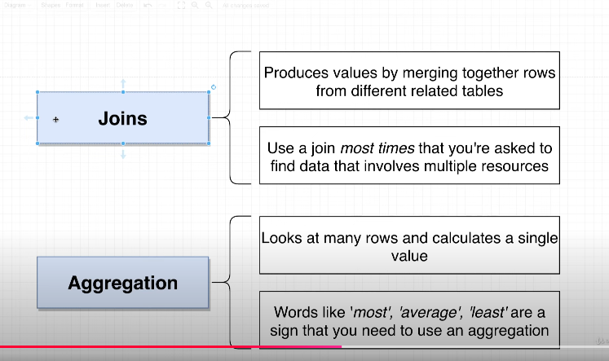

Tere are the different types of the Joins in PostgreSQL: "JOINs"

INNER JOIN: Returns records that have matching values in both tables (NAtural join or default join), except rows will not appair in resultant table.  
=>there u can use ether JOIN or INNER JOIN.

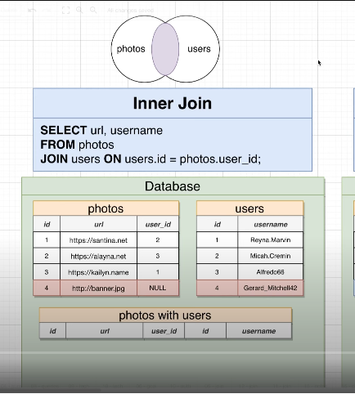

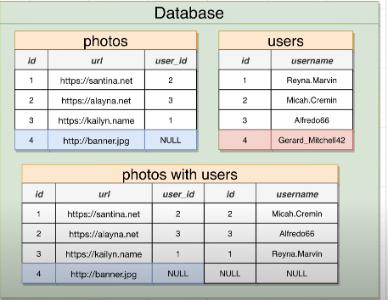

LEFT JOIN: Returns all records from the left table, and the matched records from the right table  
left table (the first table in the query)  
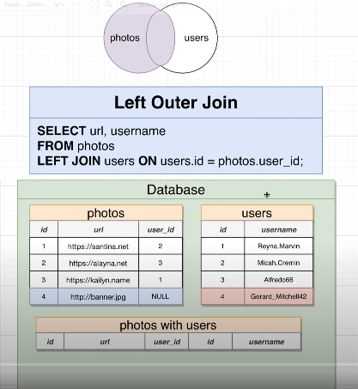

RIGHT JOIN: Returns all records from the right table, and the matched records from the left table  
 right table (the second table)  
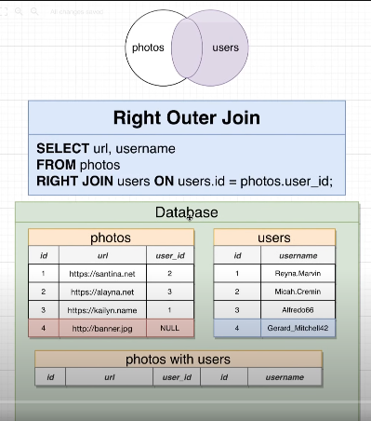  
  
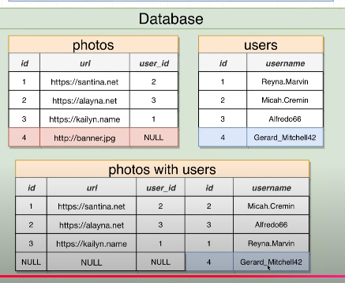

FULL JOIN: Returns all records when there is a match in either left or right table

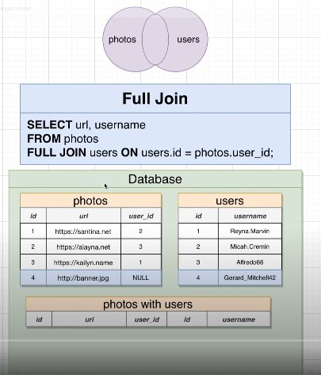

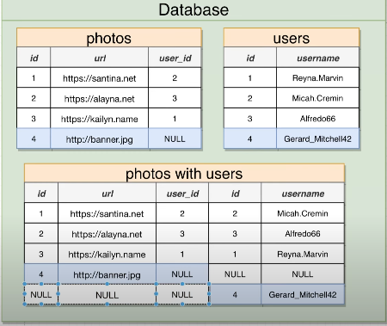

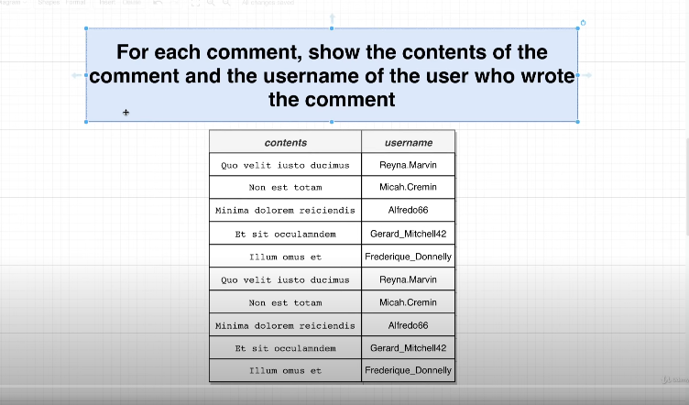  
so we have the db like this   
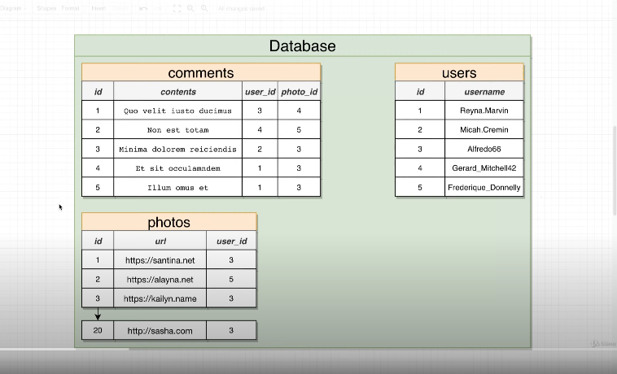

solution:  
we have to do using join's:

select commentss, username  
from commentss  
join users on user.id = commentss.user_id;  
  
  
select title, name  
from books  
join authers on books.auther_id = authers.auther_id  
  
  
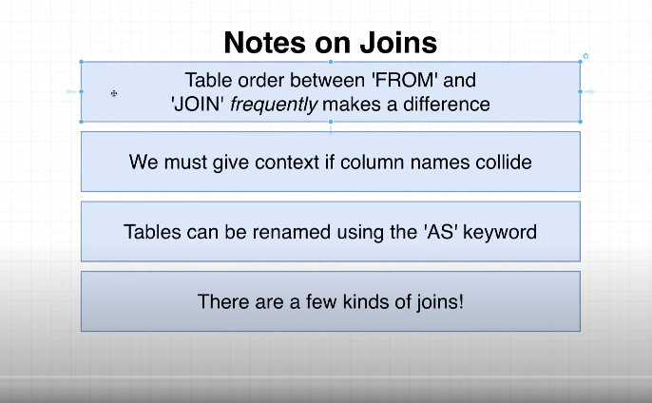

=> ambigues Error : means which value are you taking about, duplicate value.

=>that's how we can use the "As" keyword, As shows the renaming that's it.

Select comments.id AS comment_id, p.id

From photos AS p

JOIN comments ON p.id =comments.photo_id  
  
and result will come commet and id column.  
  
Q : show each phto url and user_name who posted ?

select url,username  
from photos  
join users on photos.user_id=users.id;

=> but the problem with assume query is it will not able to uses user_id "Null" in photos and we can store the value wich not belong to any user like any logo or anything for company in this case will go for Left join .  
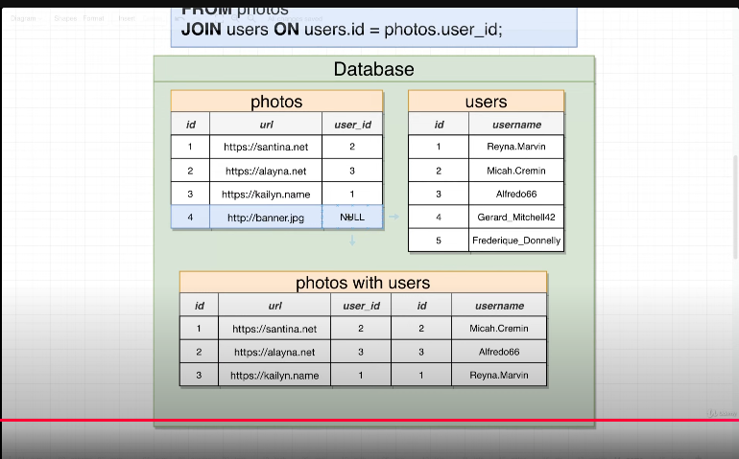

Left outer join :  
  
/*left join(left table all data, right

table matched data)*/

select url,username

from photos

left join users on photos.user_id=users.id;  
  
Right outer join:  
/* right table all data, left table mathed data*/

Q : give the user which donot have photo associate with all the username and photos:  
  
select usename, url  
from users

right join photos on users.id=photos.user_id;  
  
Q : give the username and url for matched condition even give the unmatched records also:

/* full join (all the matched data from both the table and rest all the data

with 'null' value)*/

select url, username

from photos

full join users on photos.user_id = users.id;

Q: user can comment on photos that they posted, list the url and contents for every photo  
/comment where this occured?meas **who is commenting on their own photo**?

select url, contents  
from photos  
left join commentss on photos.id = commentss.photo_id;  
  
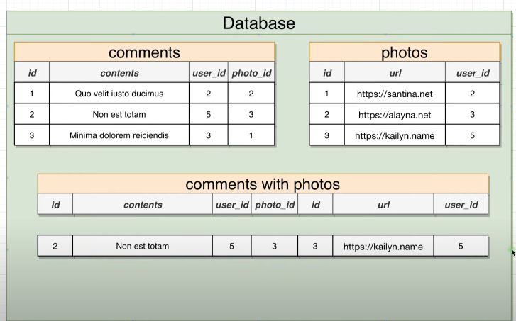  
  
=> **where use -> in below query it will run as no given:  
(Basically when you want to give one more senario/condition while selection:)  
4.select url, commentss  
1.from commentss  
2.left join photos on phtos.id= commentss.photos_id  
3.where commentss.user_id=photos.user_id;  
  
=> 3 way join=> can we join the three table data and how?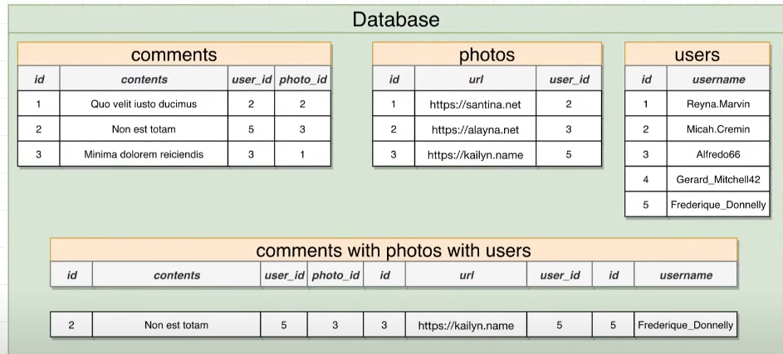 SELECT url , commetnss, username  
from commentss**

**join photos on photo.id =commentss.photo_id  
join users on users.id = comments.user_id AND users.id=photos.user_id;**

**Q: get a name, title,rating who did review of our own book?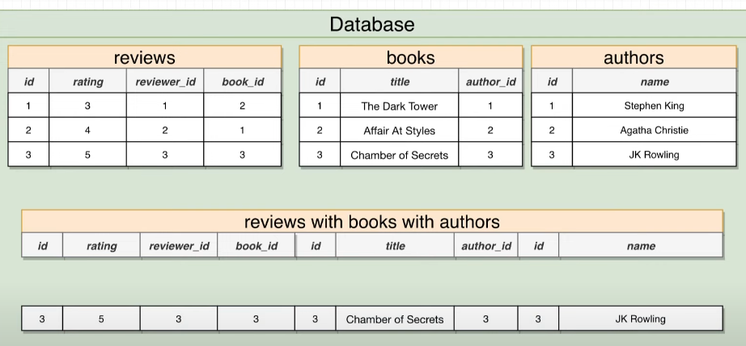 => now will check the groping and aggregation=>**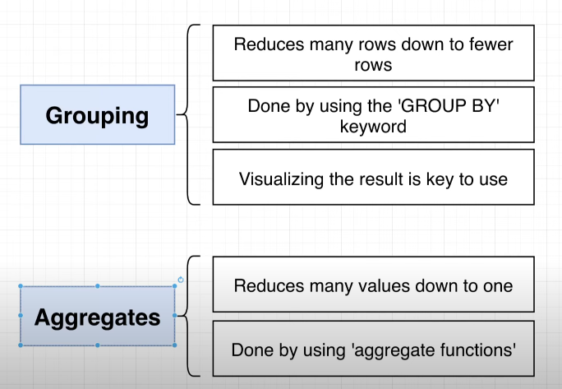

example of group by:

select user_id  
from comments  
GROUP BY user_id;

**Note: we can have a single value as a group.  
internally it will form a group using user_id: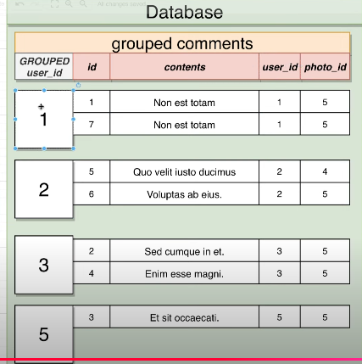 here we can't select the any row only the one which we selected which used with GROUP BY butif u want to access different coloumn than use the aggregation.  
Aggregate function:**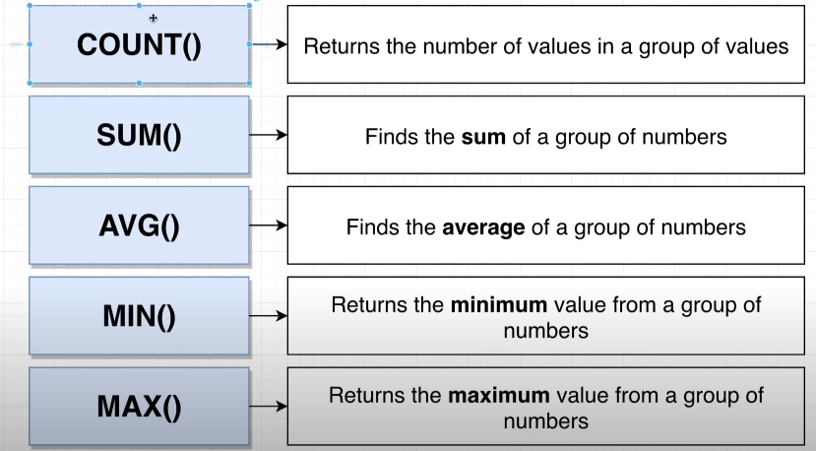

**note: we cannot select the column and aggregate at the same time in select statment:  
ex:  
SELECT SUM(ID), ID  
FROM COMMENTS; -- THIS WILL THROW ERROR SAYING MUST APPEAR IN GROUP BY CLAUSE.  
  
=> combine the GROUP BY and AGGREGATION Function together:  
  
Q: give the group of user_id and find the maxx of id in this group?**

3.select user_id, MAX(id)  
1.from commetnss  
2.group by user_id;  
  
Note: in aggregate count(), null value will not be counted for instance if u r trying to  
count the column which contains than this row will going to miss for that we can use :  
count(*).  
  
Q: Find the number of comments for each photo?  
-> firstly think whethear u have to get the data from same table and another if same than donot bliendlly go for join.  
  
select photo_id,count(*)  
from commentss  
groupby photo_id  
  
   
Q: give the aouther id and no of book auther written:  
  
select aouther_id,count(*)  
from books  
group by author_id;  
  
Q: authors name and the no of book they have authered  
  
select name, count(*)  
From auther  
join books on authers.id = books.auther_id  
group by authors.id;   
  
Q no of comment one user made :

select user_id,count(*)

from commentss

group by user_id

having count(*) >= 1;

Q: give the no of commentss user made with user Id.  
  
select user_id,count(*)

from commentss

left join users on users.id = commentss.user_id

group by commentss.user_id;  
  
  
  
=> EXECUTION ORDER=>  
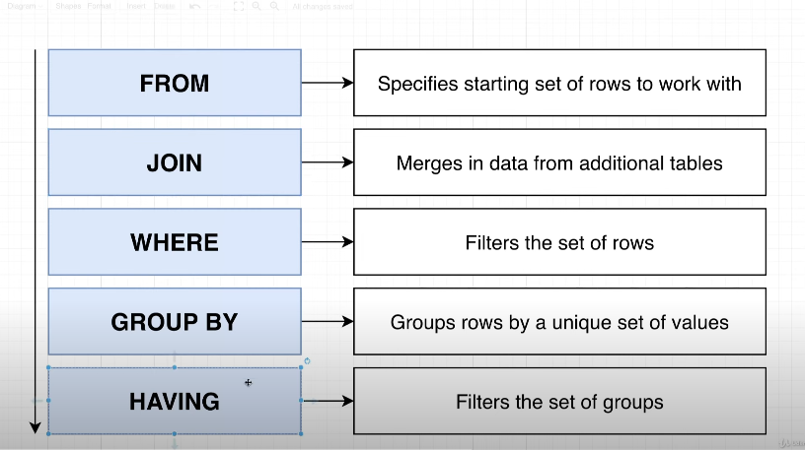  
Note: We can't use "HAVING" withuot GOUP BY.  
=> 1st where runs then group by runs.

=>'where' runs on some no of rows and 'Having' runs on some no of groups.   
  
Q:find the no of commentss for each photo where the photo_id is less than 3 and the photo has more than 2 commentss?  
 **select photo_id,count(*)  
from photo  
where photo_id<3  
group by photo_id  
having count(*)>2; --If u see HAving clause chances are to use aggregate function in it.  
  
  
Q:** Find the user_ids (users) where the user has commented on the first 10 photos in table itsef and the user himself added more than or eqaul to 2 comments on this 10 photo:  
  
select user_id, count(*) -- no of commentss each user has created.  
from commentss  
where photo_id <=10  
group by user_id  
having count(*)>=2;  
  
 **Q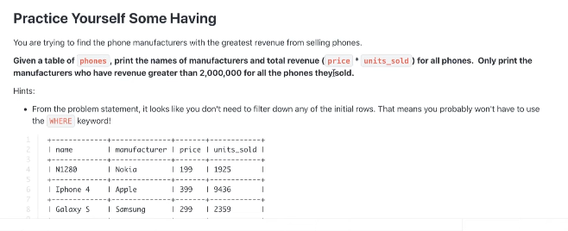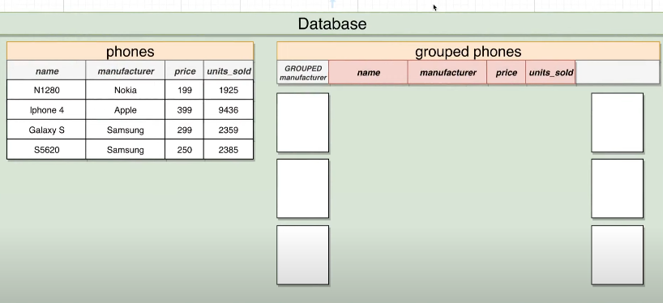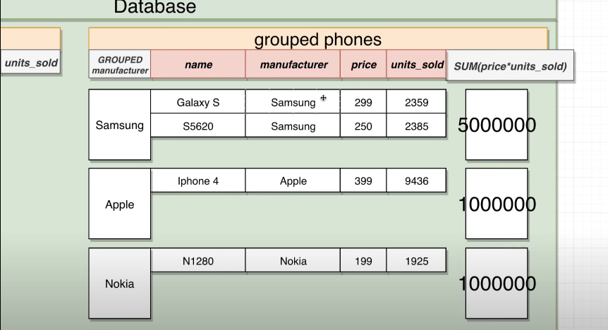 result u want than form there you can filter.  
  
select name, SUM(price*unit_sold) as revenue  
from phones**

**group by manufacturer**

**HAVING SUM(price*unit_sold)>2000000;  
  
Q: find the user name and the total order amount is greater than 550 ?**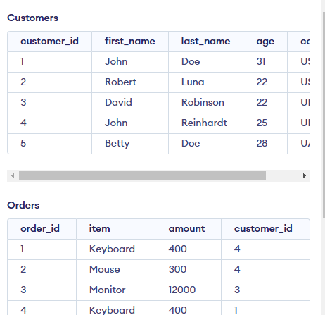

**SELECT first_name || last_name, sum(amount) as Total_order**

**from Customers**

**join Orders on Customers.customer_id=Orders.customer_id**

**group by Customers.customer_id**

**Having Total_order>550;**

**Note: In many: many relationship many dependency from bith the side.  
  
  
Q : write a query ti find paid and unpaid orders: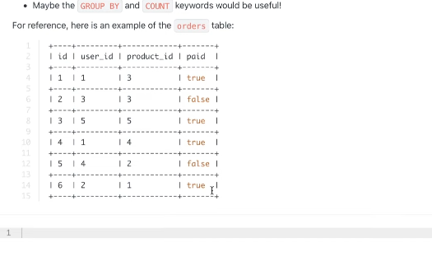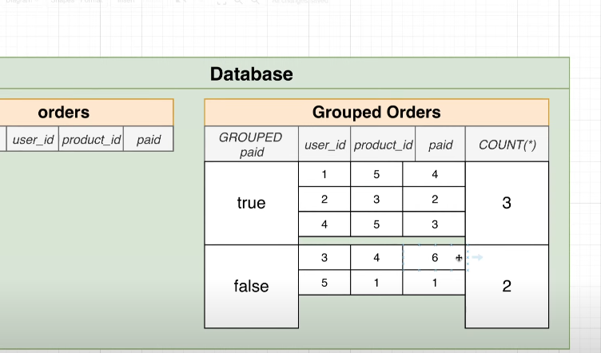 Select paid, count(*)  
from orders  
group by paid;  
  
Q: give the first and last name of the user how have paid the money?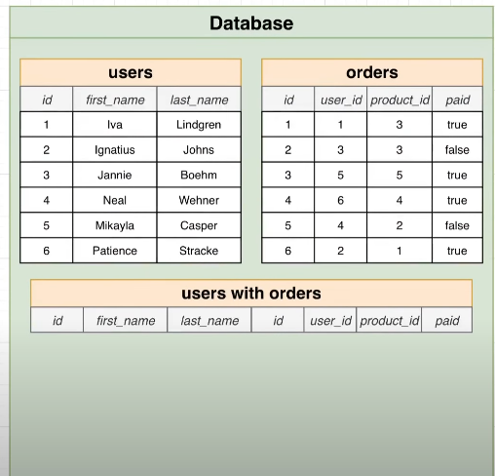 select first_name || last_name  
form users  
join orderes on users.id= orders.user_id  
group by user_id  
having paid= True;**

=> **Shorting records: ACS and DESC.**

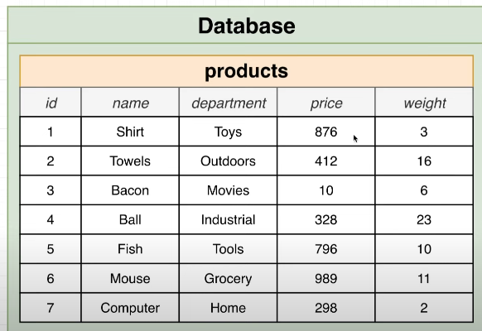 **Q : get all the data from the table and sort it by price low to high?**

**select *  
from product   
Order by price ASC; -- by default ascending order have to follow.  
  
Q: get all the data from the table and sort it by price high to low?  
  
select *  
from product   
Order by price DESC;  
  
Note: Shoring happen low to high in number and alphabetical in string.  
But assume if two order have same price in this case will follow the second order way:**

**select *  
from product   
Order by price, weight; -- if price is same than short by weight.  
  
________________________________________________  
  
=> OFFSET(SKIP)and LIMIT(till max no of record):**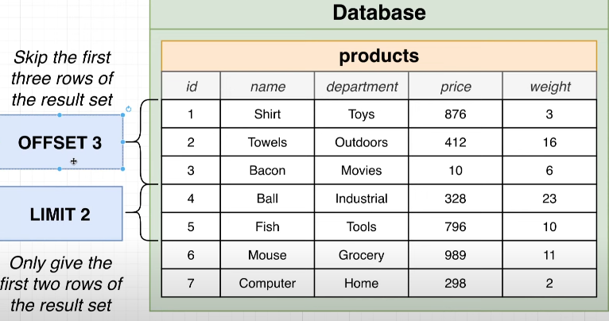

**ex:  
Select *  
from users  
OFFSET 3;  
  
select *   
from users  
LIMIT 5;**

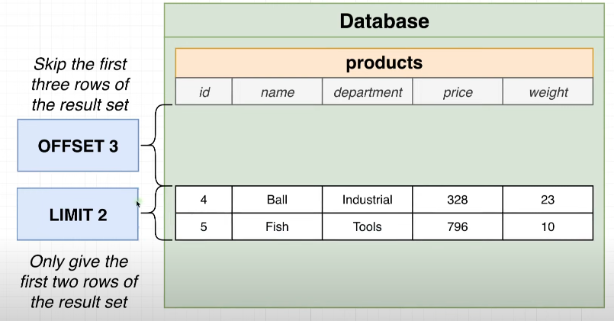 **Q: 5 most expensive products?  
  
select *  
form Product  
Order by price;  
Limit 5;**

**Q 5 least expensive products?  
  
Select *  
oredr by price desc  
limit 5;  
  
Note: OFFSET always comes after LIMIT.  
ex:  
  
Select *  
from Products  
oredr by price desc  
LIMIT 5  
OFFSET 1;  
  
=> In Ecommerce website large data to show in this case we have to show limited data in one single screen using LIMIT and OFFSET :  
  
Select *  
From products   
order by price desc  
Limit 10  
Offset 0; -- It means 0th page will show 0 to 10 record in 1 page  
  
Q: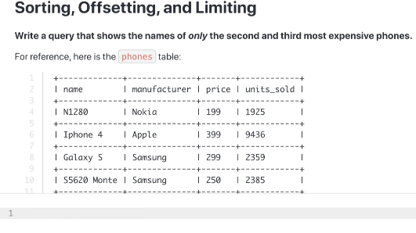 Select *   
from Phones  
order by price asc  
limit 3  
offset 1;  
  
  
 UNION: MERGE 2 OR MORE QUERY:**

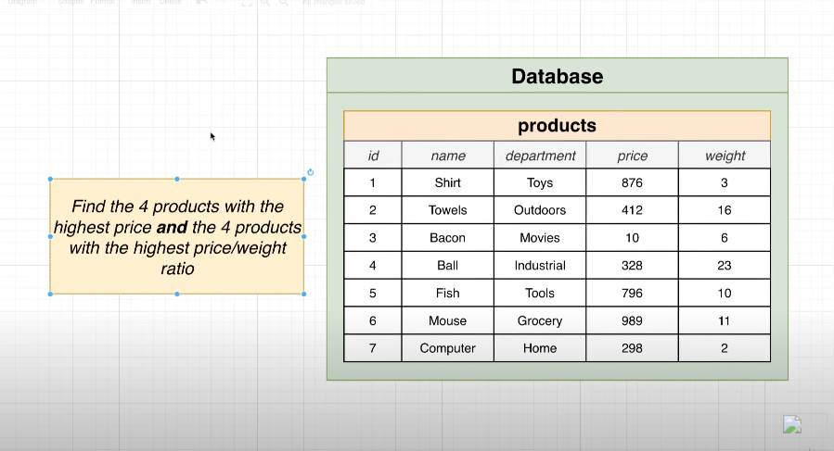  
Q: 4 Highest salary and ratio of price/ weight(cost effeciate so seap it ):  
  
(Select name  
from products  
order by price asc  
limit 4)   
UNION  
(select name  
from products  
order by price/weight desc  
limit 4 );  
Note : If any record is repeating in result union only show once in table(unique record).  
  
Note : Difference between UNION and UNION ALL is UNION gives the unique record and UNION ALL gives the all the matched record with deplicate record.  
Note: There should be logic while UNION it should not just different query to match   
ex:NOT WORK :: ERROR   
 SELECT name FROM products   
UNION price FROM products;

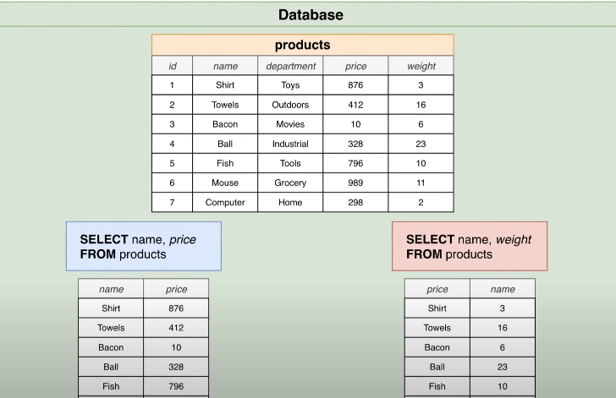

other Keywords :  
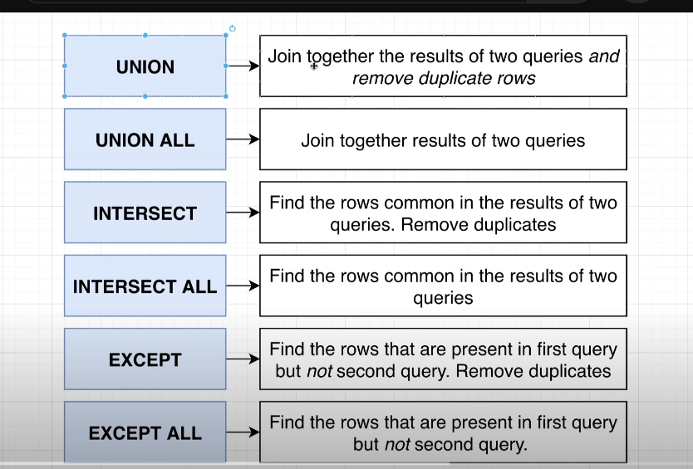

=> Intersect is a row to comman in both the table:  
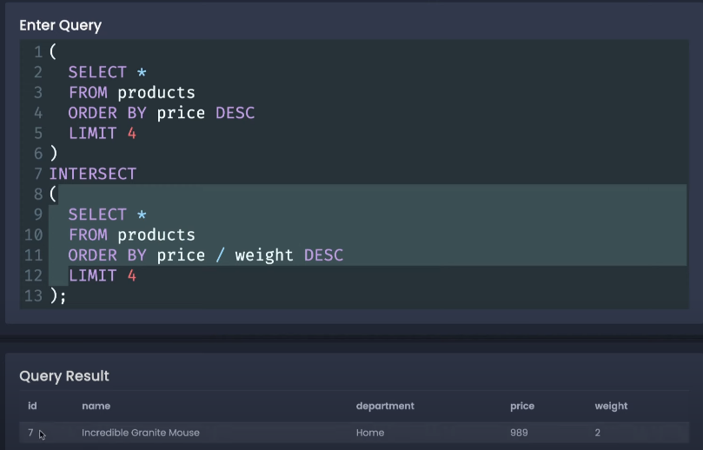

Note : In case of EXCEPT main table is LEFT TABLE it does not matter hoa many rows present in right table.  
=> in EXPECT the order of the table matters, if we change the order it matters in final result table.

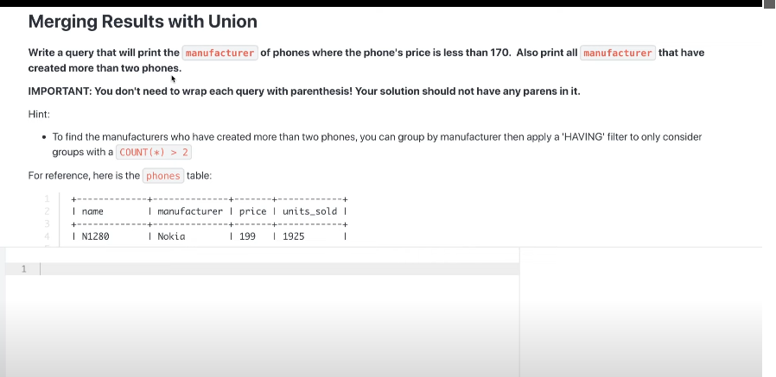

select ­­­­­­­­­­manufacturer  
From Phones   
where price <170  
UNION  
SELECT ­­manufacturer  
From Photos

GROUP BY manufacturer  
Having count(*)>2;  
  
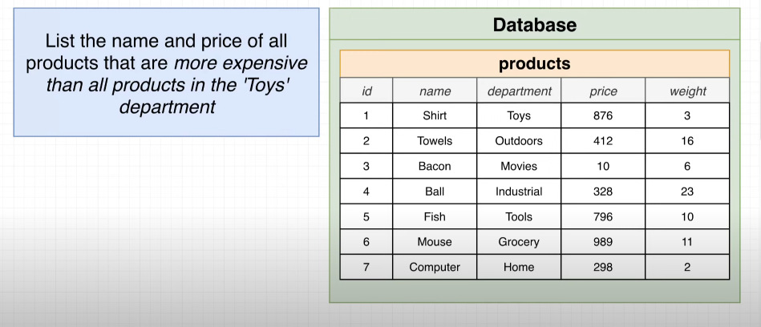  
  **SUBQUERY:**  
=> when you have to dependent on other query than we go for subquery.  
  
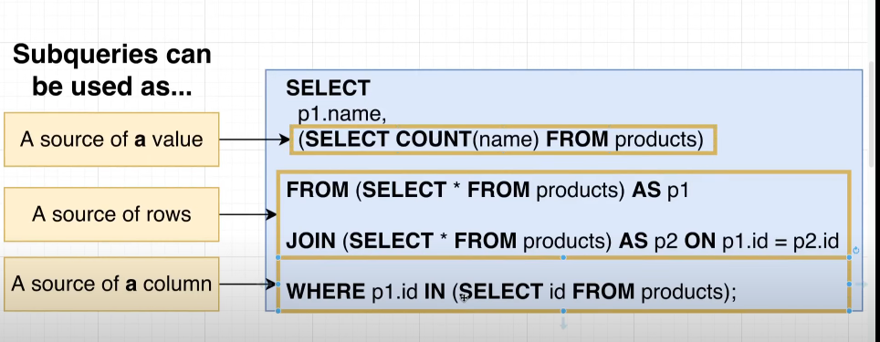

ex:  
Select name, price  
From products   
where price> (select max(price) from products where depaetment= 'Toys');  
  
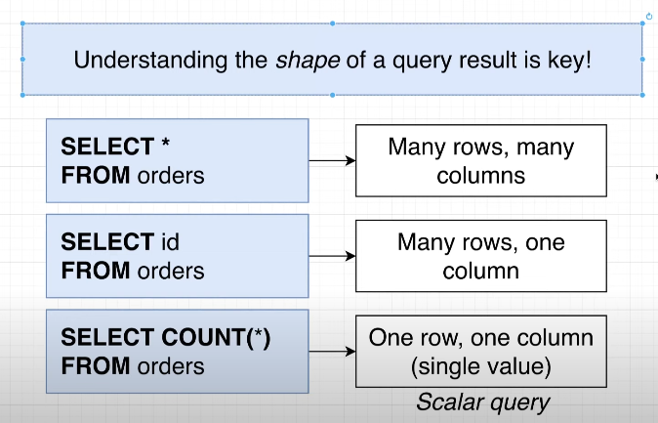

Note=> when you giev the subquery as in select statement, in this case subquery should return the 1 result, and this one result will come into the main result as well.  
  
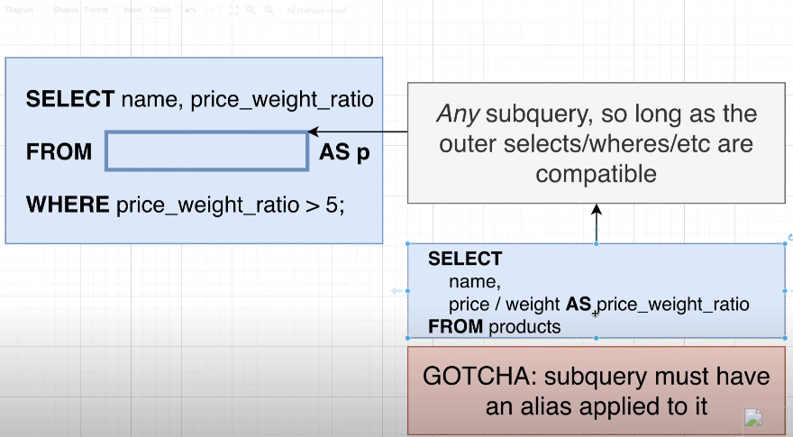  
  
=> here we have to alias the subquery data to we can refer it again somwhere in main query .  
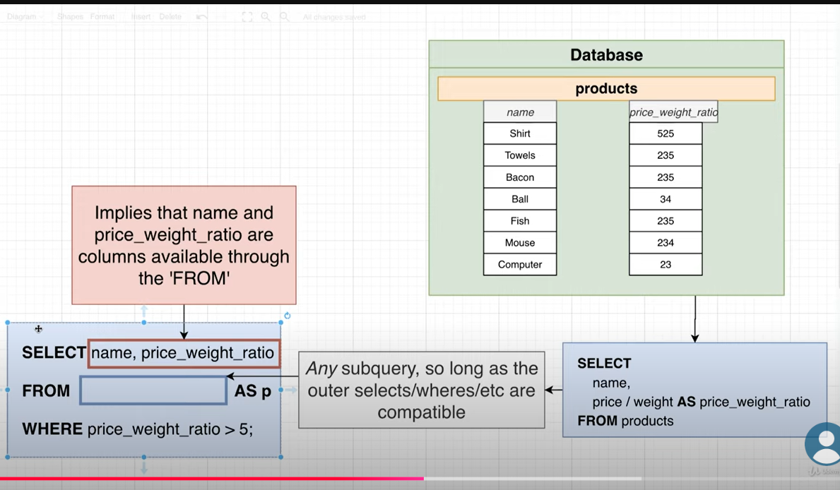

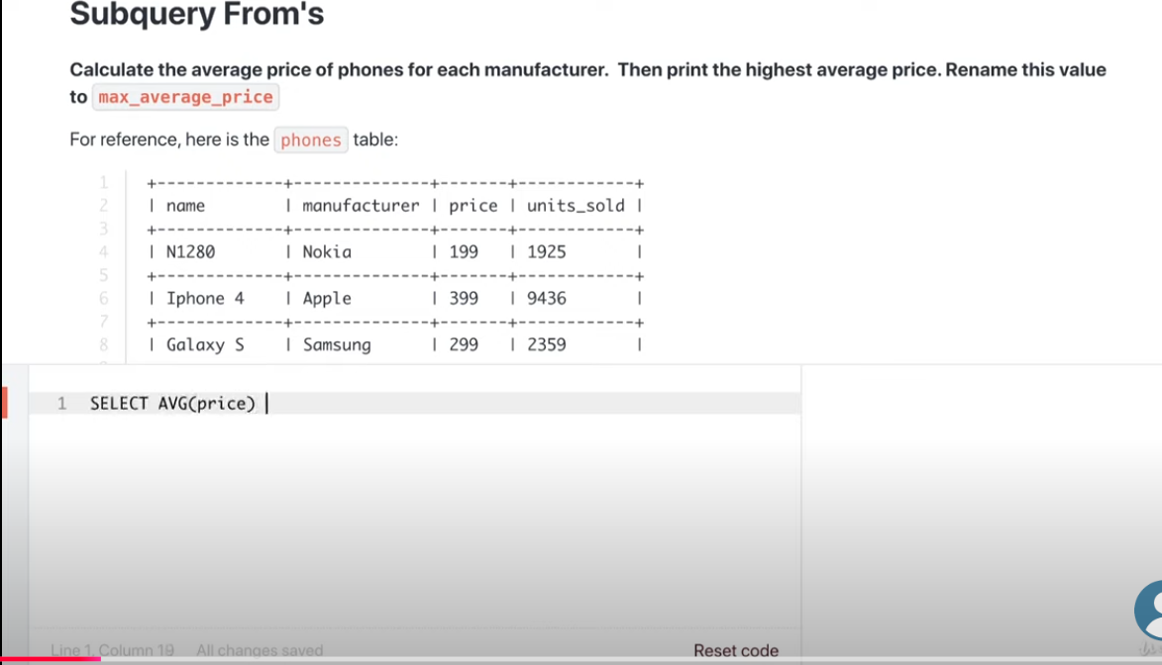  
  
Solution:

Select Max(P.avg_price)

From (Select AVG(price) as avg_price   
 From Phones  
 group by manufacturer  
) as P;  
  
  
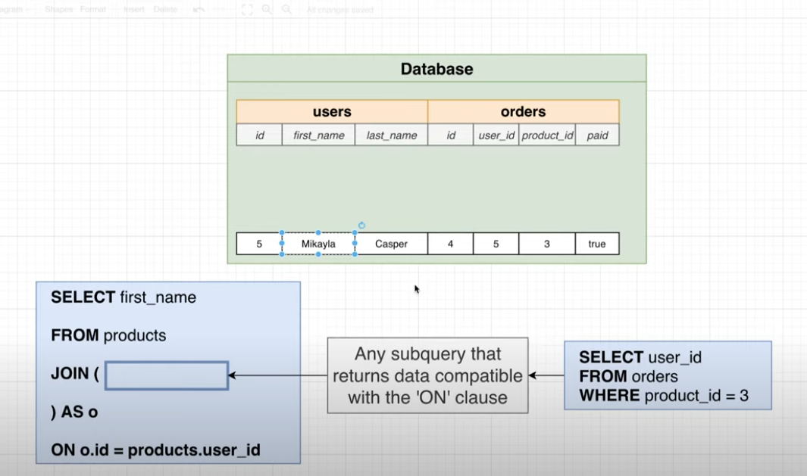  
  
EX:

Select first_Name  
From users   
JOIN (Select user_id   
From orders

WHERE product_id =3) AS O  
ON O.user_id =users.id;  
  
  
=> Subquery inside the Where clause :  
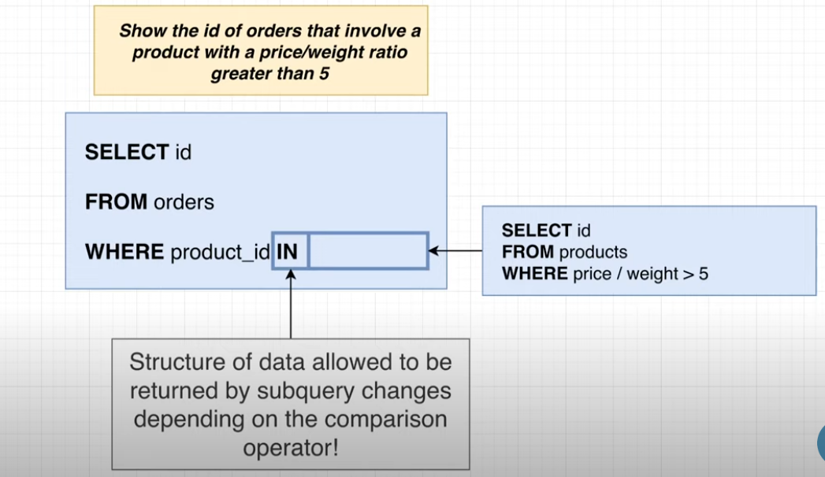  
  
Select id   
From orders   
where product_id IN (select id   
from products where price/weight>50);  
  
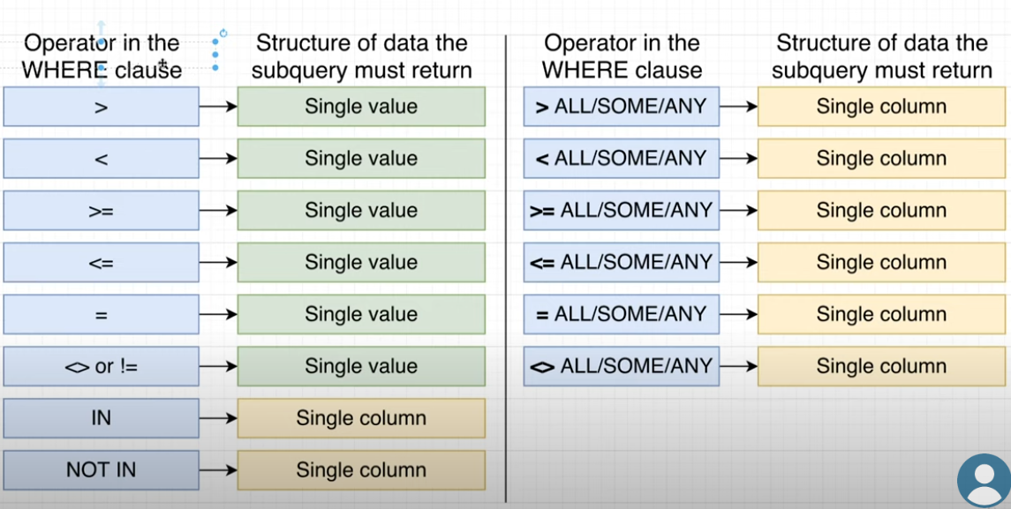  
  
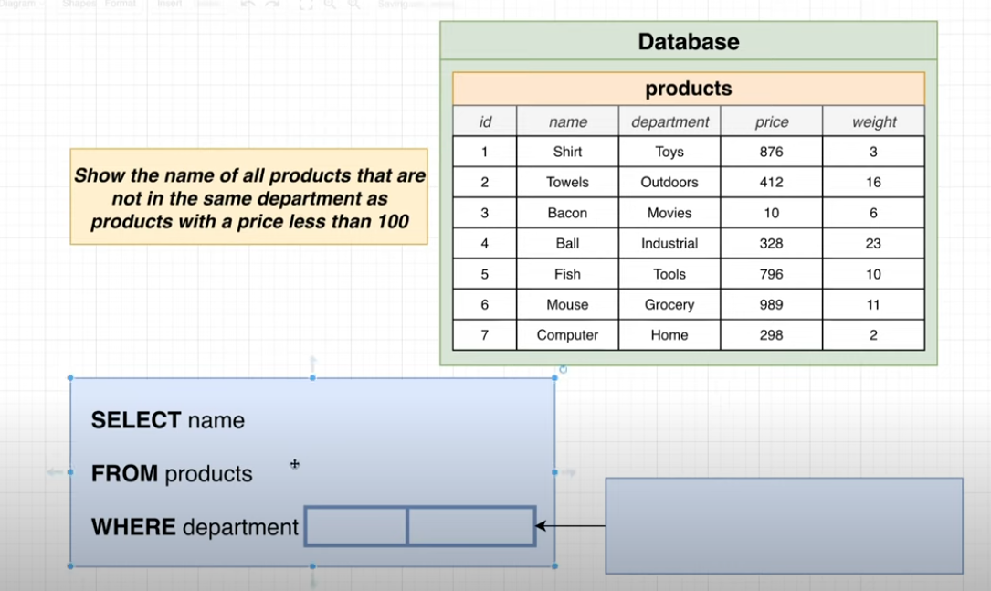  
 Solution:  
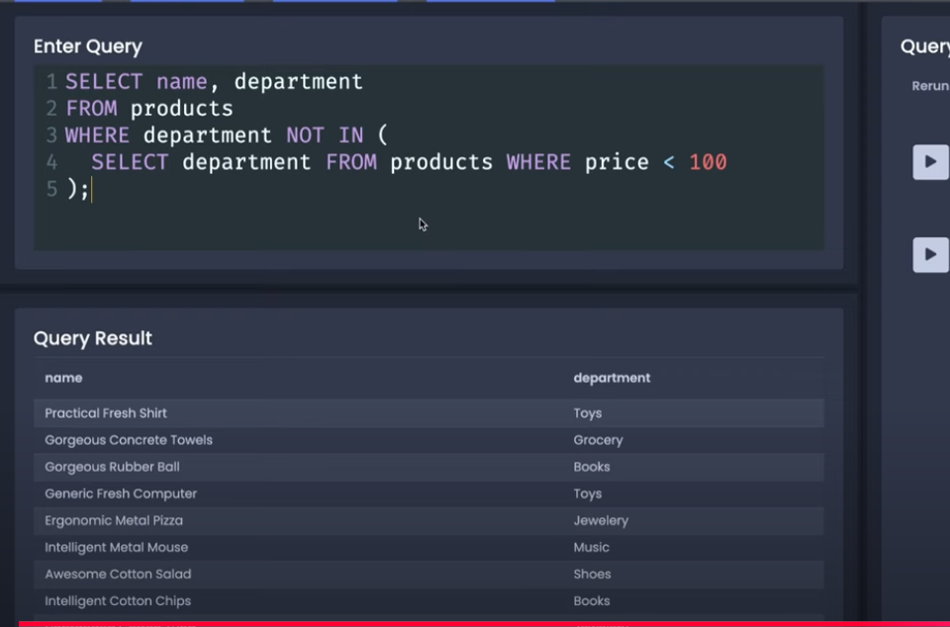  
  
=> Few operators need to remember =>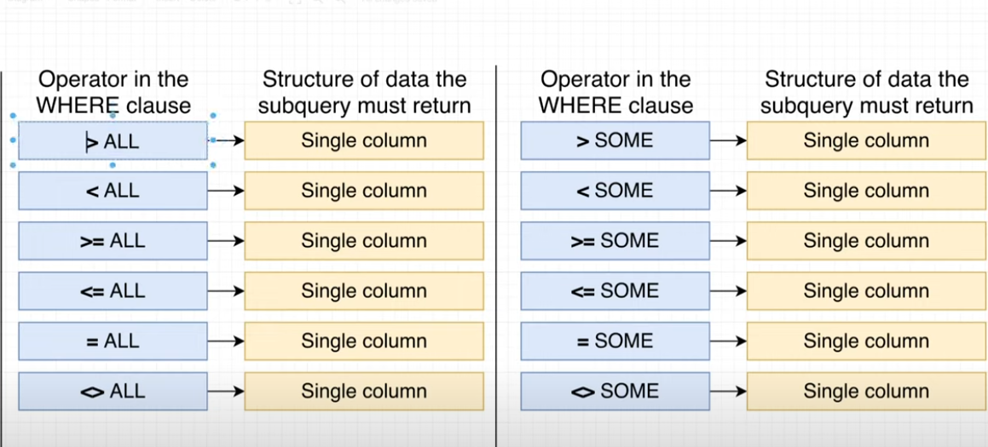  
  
=>Note : > SOME or >ANY both operator are same.  
ex:   
50 <some (20,100)-🡪 True  
50 > some (20,100) -🡪 True  
(because at least minimum 1 value should follow the rule. )  
  
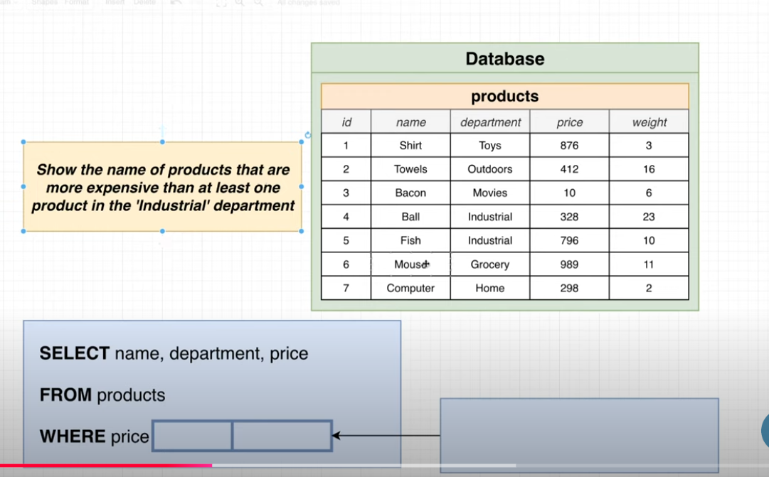  
  
SELECT Name, department, price  
From Products  
where Price >SOME (select price  
from products  
where department = ‘Industrial’);  
  
 Co –related Subquery(Basically we are reffering outer and inner query by correlate via alias name like p1 or p2 below.)  
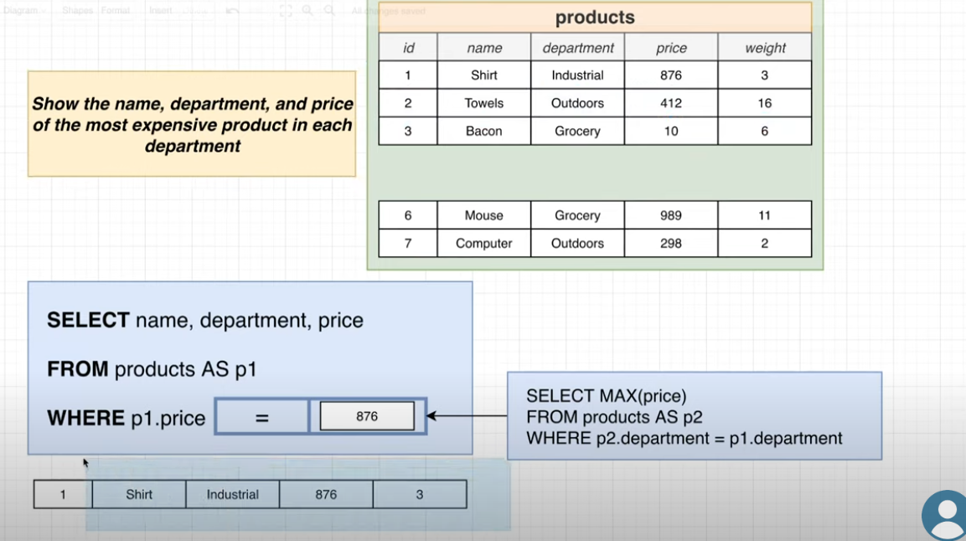  
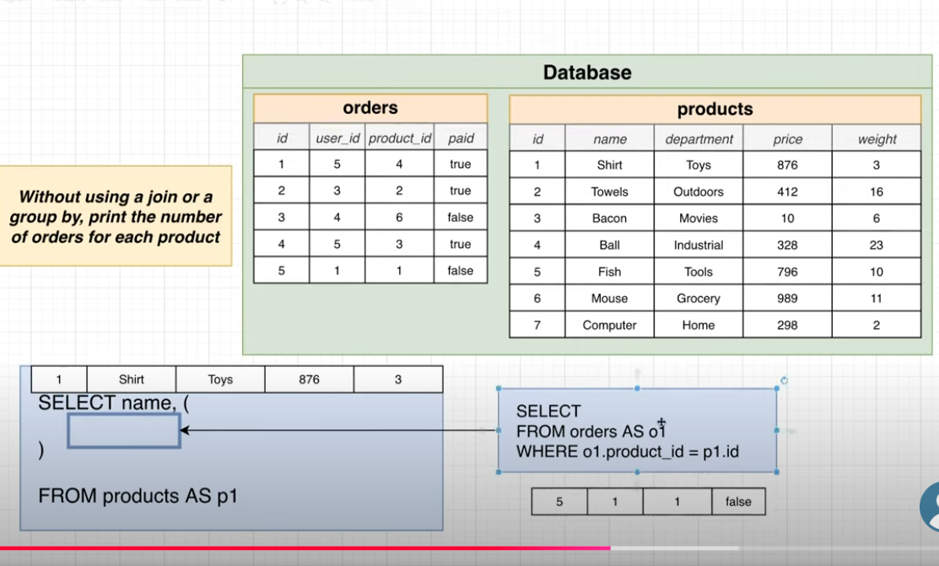  
   
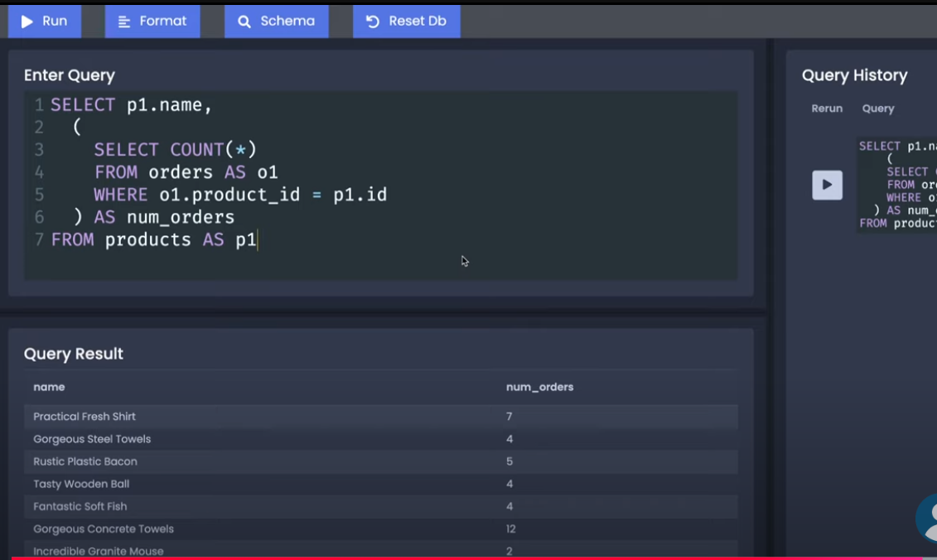  
=> If you have a subquery than select only can return the value no need to give FROM …  
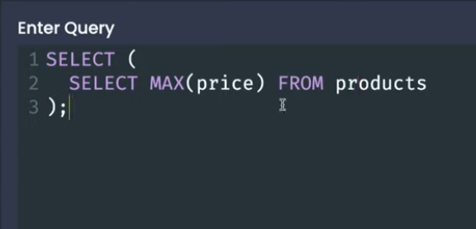  
  
=> New Keyword in SQL :  
 1. **DISTINCT**: Always comes with select to filter the unique value from the resultant table.  
  
 ex:   
Select DISTINCT department  
From products;  
  
Note: you can use group by instant of distinct but we can’t use unique instant of group by.  
Note: but if u apply more than 2 row distinct we can’t use COUNT() on it.

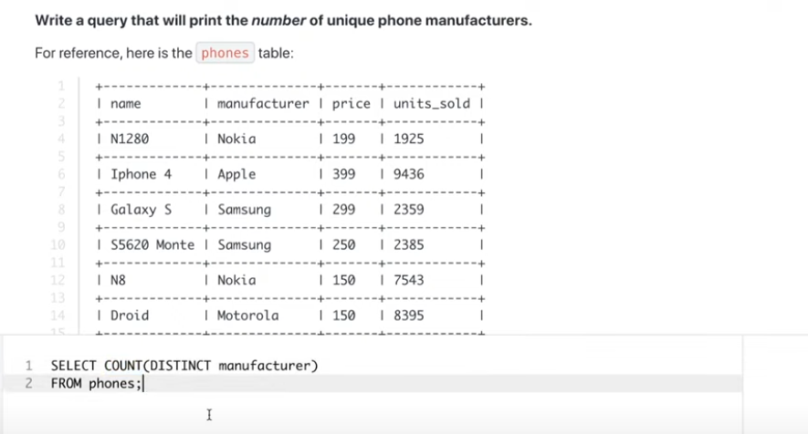  
=>We have the GREATEST function to find the max value in list   
=> Same like we have the LEAST () for minimum value.  
  
ex:  
select GREATEST(200,10,40)  
o/p: 200  
ex:   
select LEAST(200,10,40)  
o/p: 10  
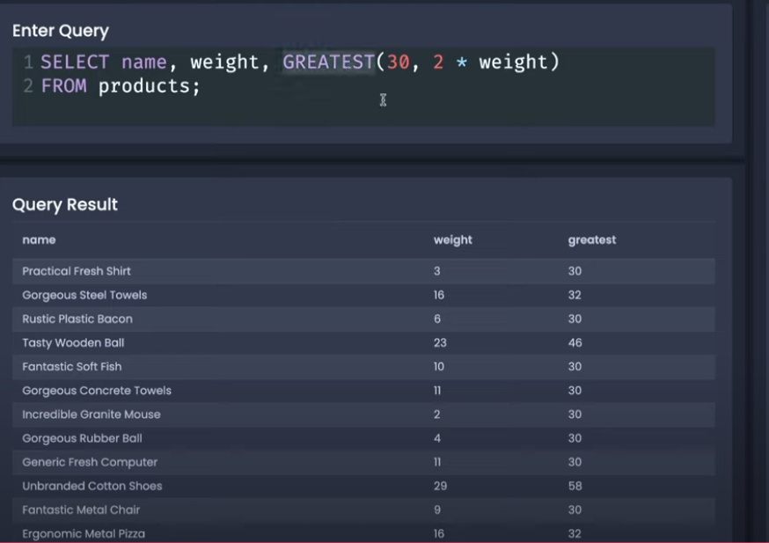  
  
This is LEAST example:  
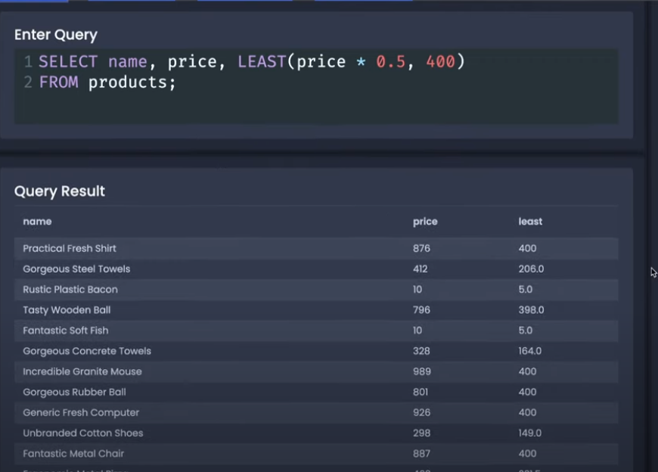  
Q : We will use the the “CASE” Keyword here .  
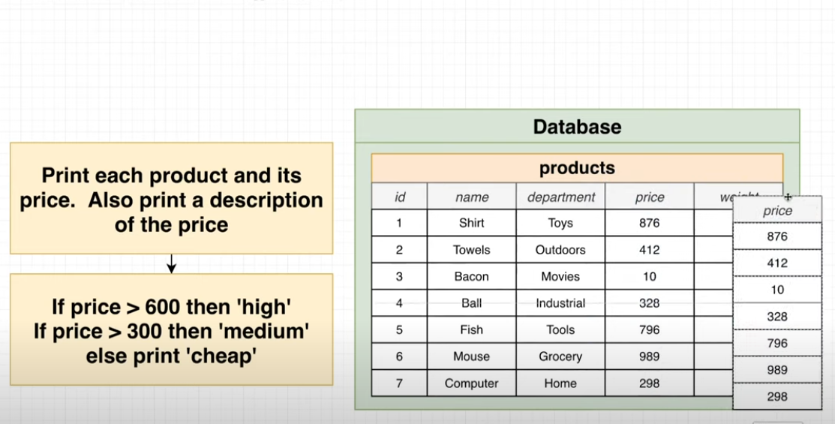  
  
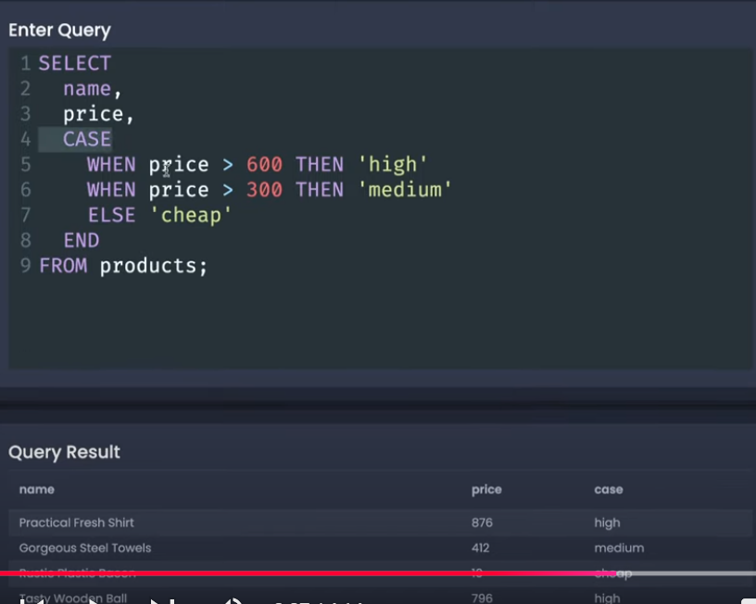   
  
  
 **PGADMIN and PostgreSQL NOTES :**  
Note:  
=> PGAdmin is the UI interface of Postgres to manage the db, you can probably do anything with it to ur db.  
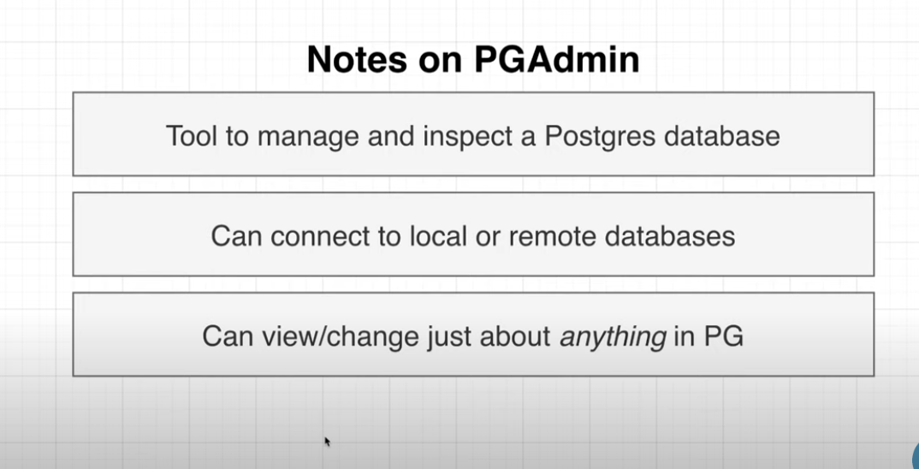  
=> In Postgres we have the servers, by default our db use to keep inside into the default server.  
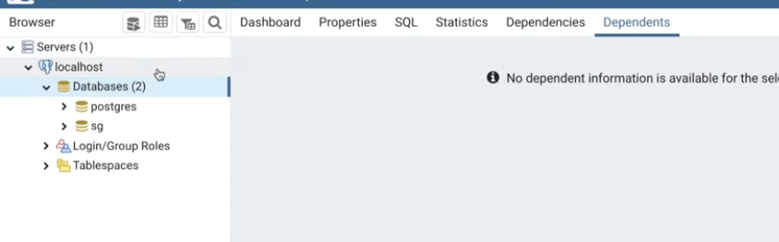  
=> Remember one DB need to contain one app information only.  
=> One server can have multiple DB inside it.

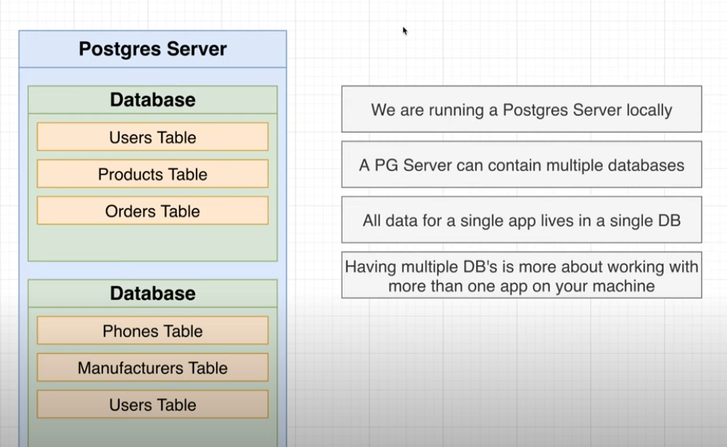  
=-> Default port of pg admin is 5432.  
  
  
=>SOME EXTRA Data Type in POSTGRES:

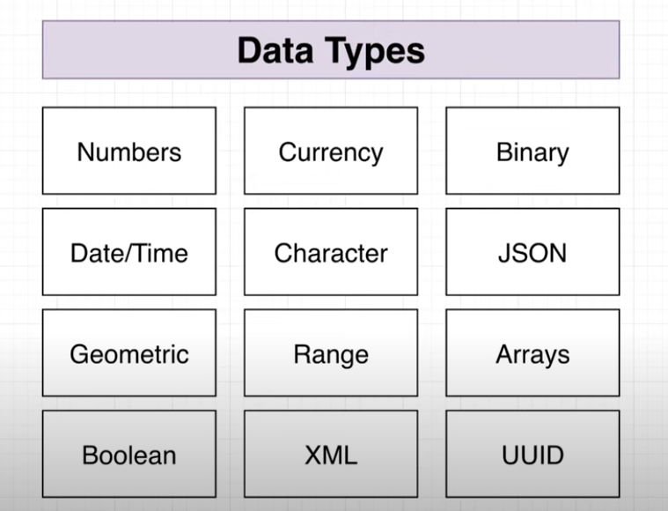  
  
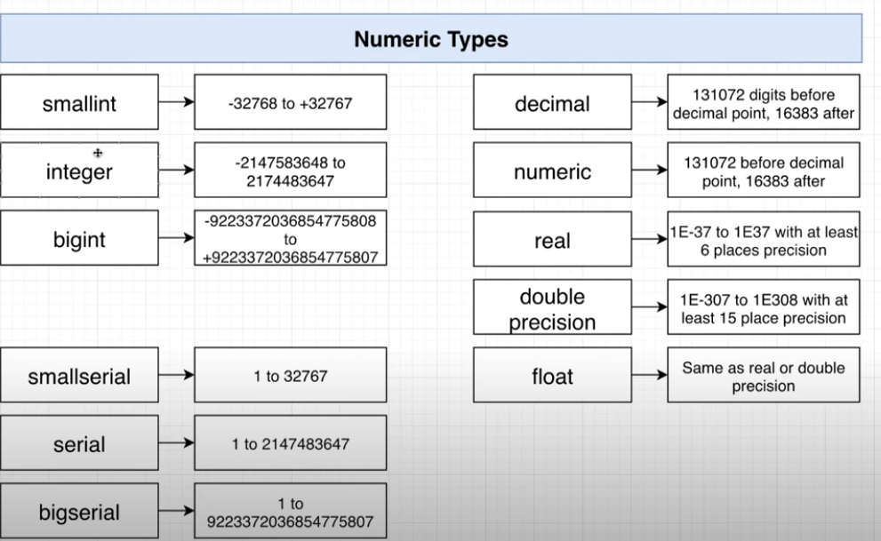  
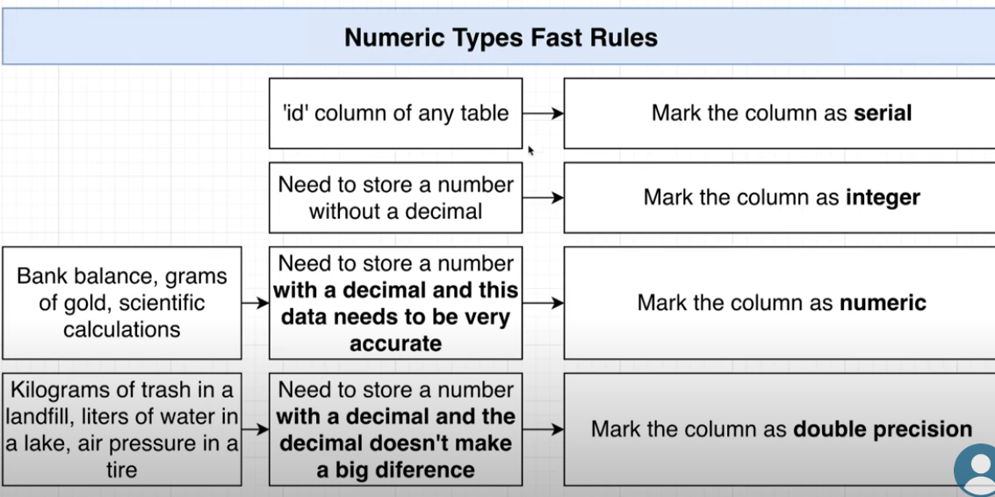 **Note**=> Follow this rules whenever you are giving the numeric value:  
-> Whenever you have to mark us a id 🡪 **Serial**  
-> without decimal 🡪 **integer**  
**->**decimal or float 🡪 **numeric(exact amount have to store)  
->N**umber can be mismatch(Approximate)🡪**double precision  
  
-> If we say postgres to take our value in different data type, it will store in different data type manner:  
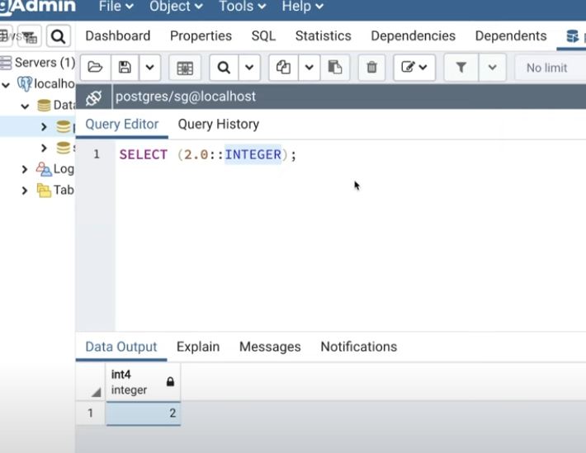  
=> smallint data type will store the value in round up manner 3.8 will be like 4. (range of smallint is -32768 to +32767)  
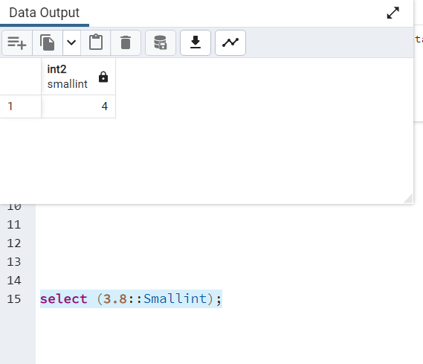  
-> will get the error out of smallint range (-32768 to +32768).  
  
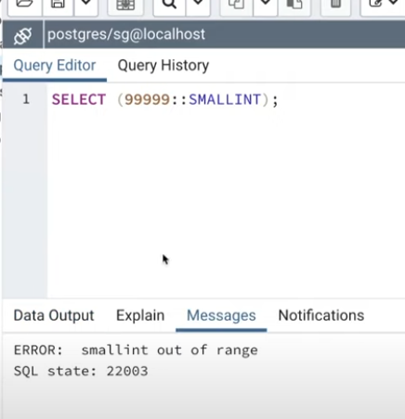  
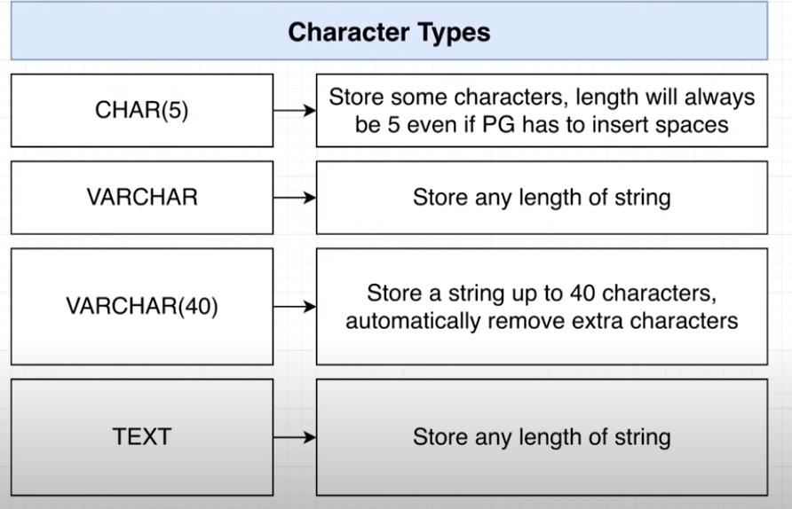  
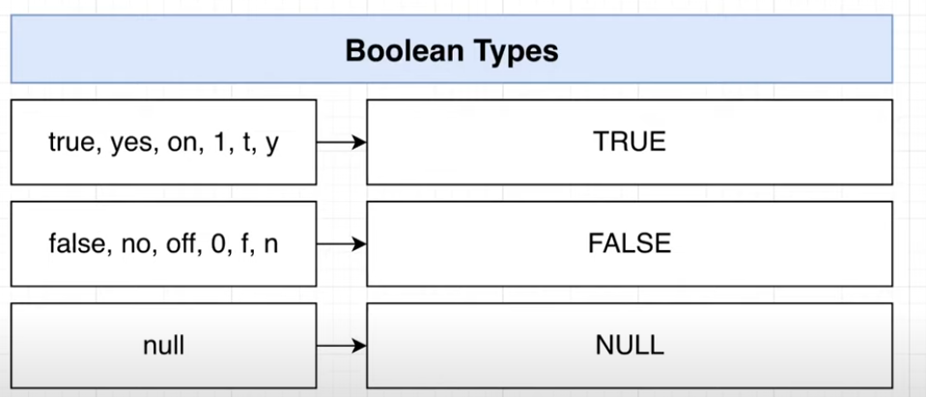  
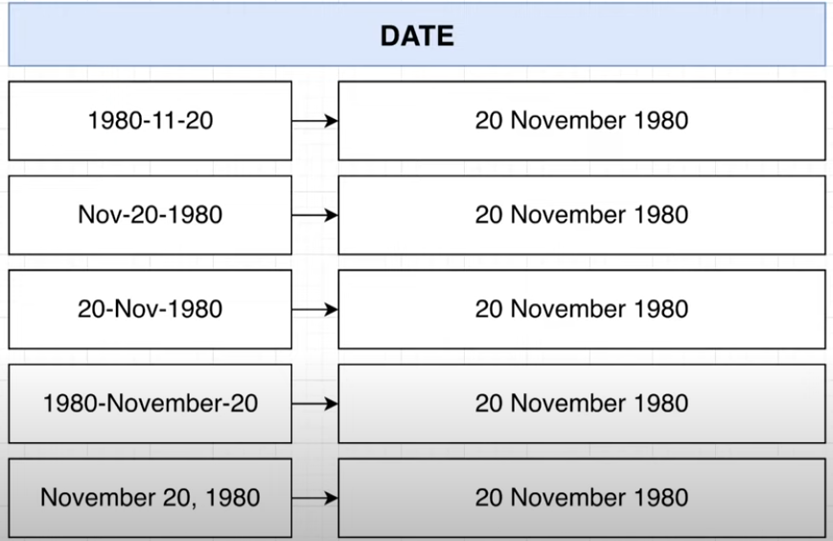  
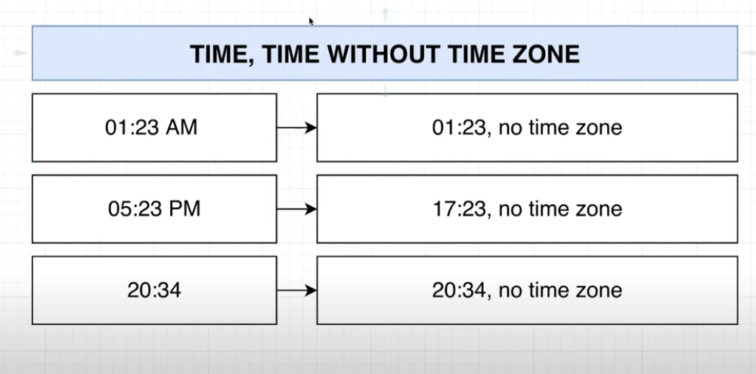  
  
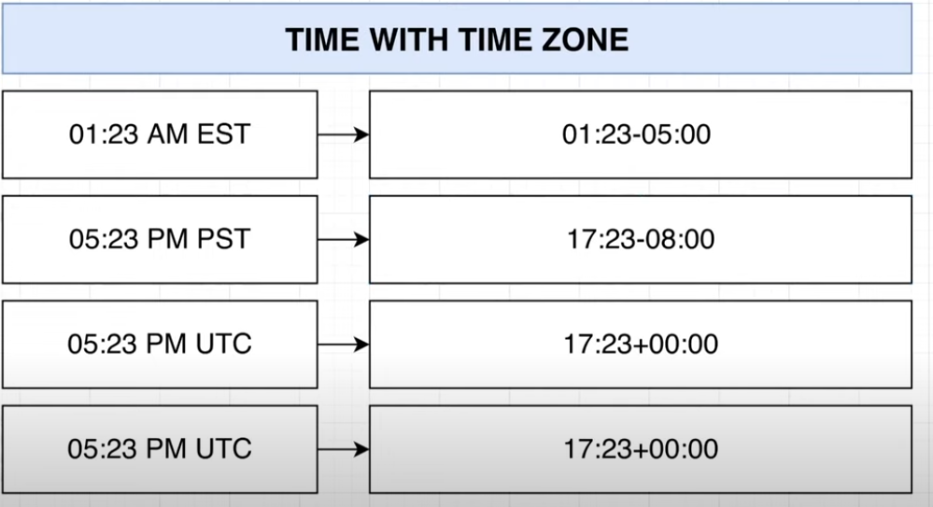  
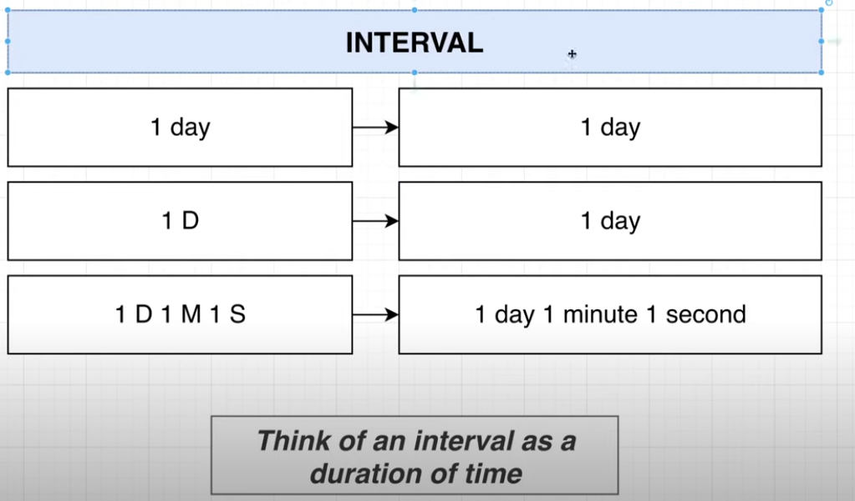  
  
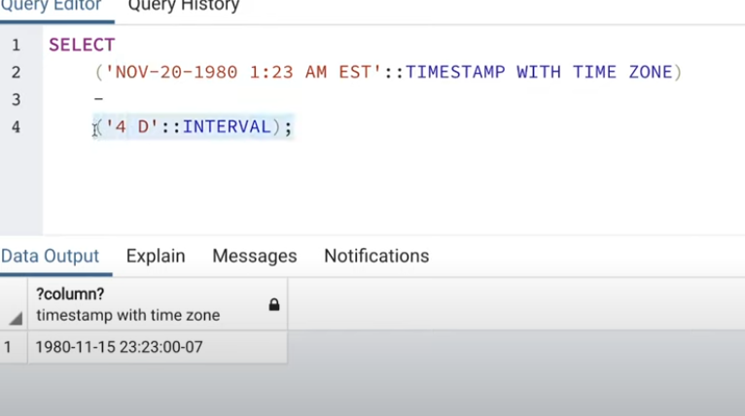  
  
 =>** VALIDSATION BETWEEN THE DATABASES:  
 **=> in Scenario one some admin user trying to add false data into the db using the web server.**  
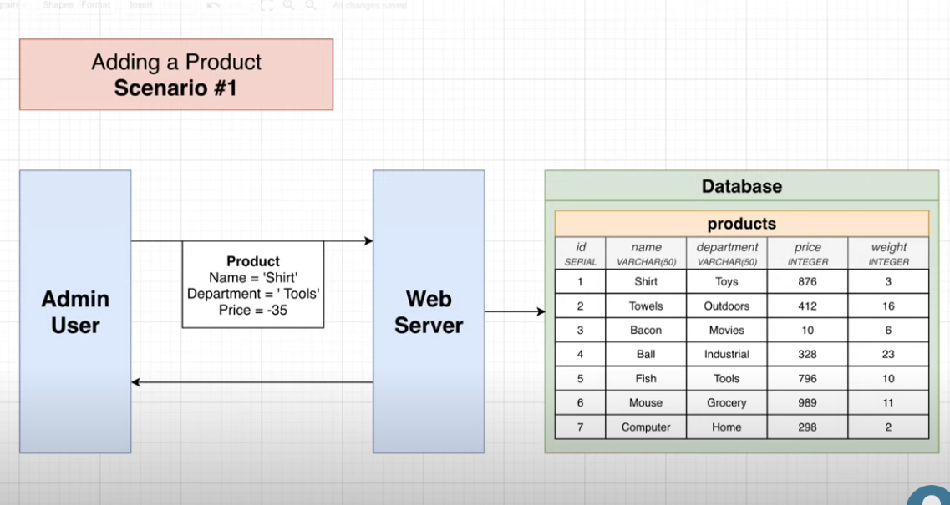  
=> In Scenario 2 Admin directly trying to add the false product to the DB using the PGadmin DB interface. In both the scenario we need the validation while intering the data into DB.  
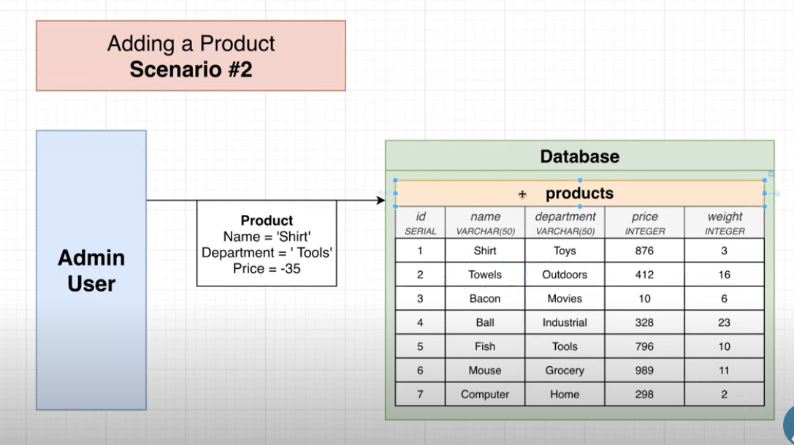  
=>  
  
  
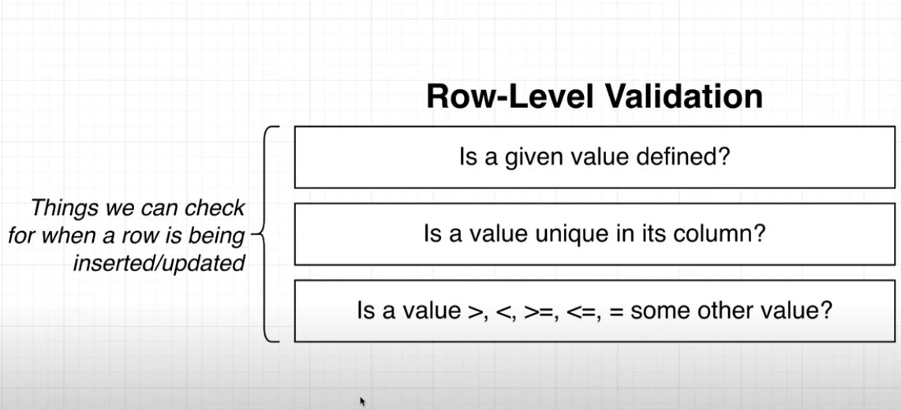  
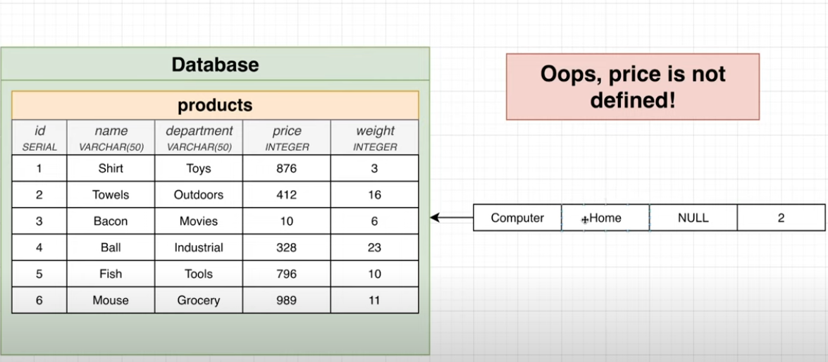  
  
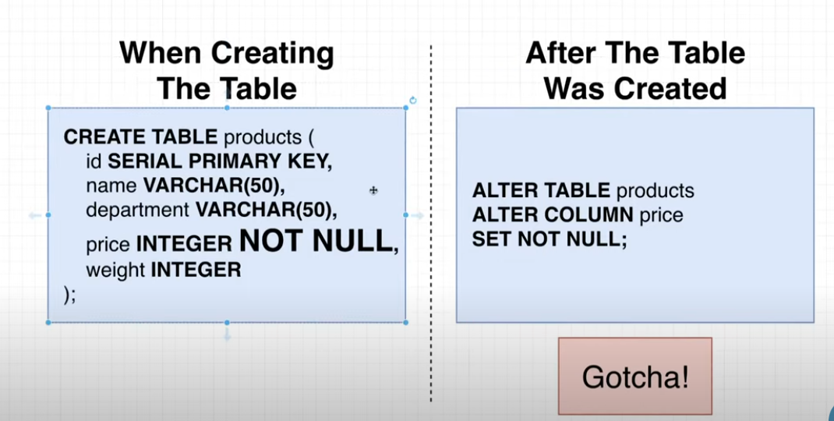  
 Even we are trying to add the constrain it is giving the error like null value already contain:  
2 choises - > 1. Ether delete the data and make chances in schema or   
2. Find the NULL value and update with somevaue so you can refer it after sometime.  
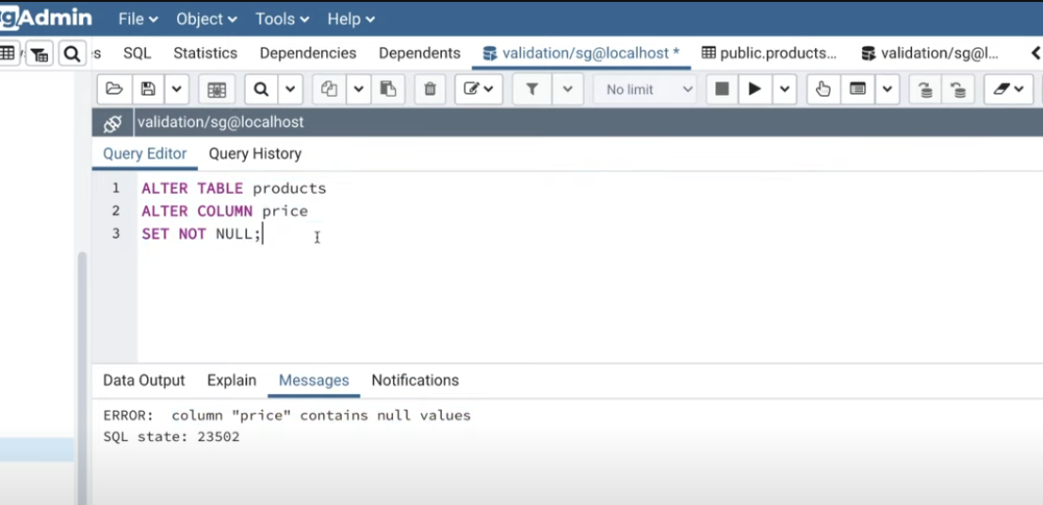  
  
=> This is one of the way we can update the value at a movement.  
=> After this we run the ALTER table command, than whenever we will try to insert the false value we will get the error.  
  
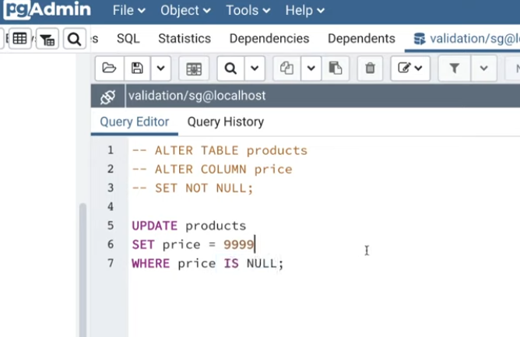  
ERROR WE EXPECTED while putting the false record in table:  
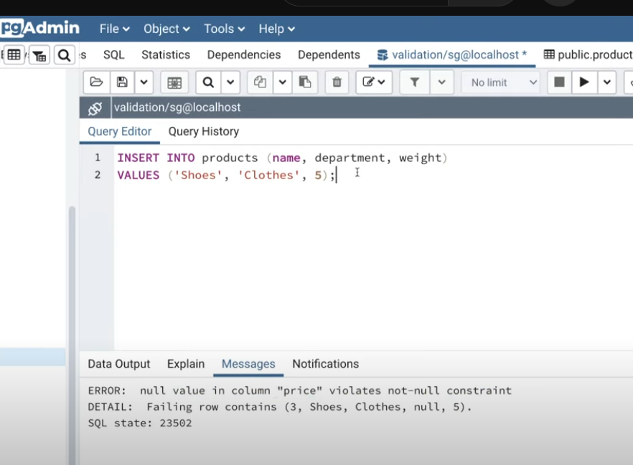  
=> If Price is not defined in this case you can mention the default value.  
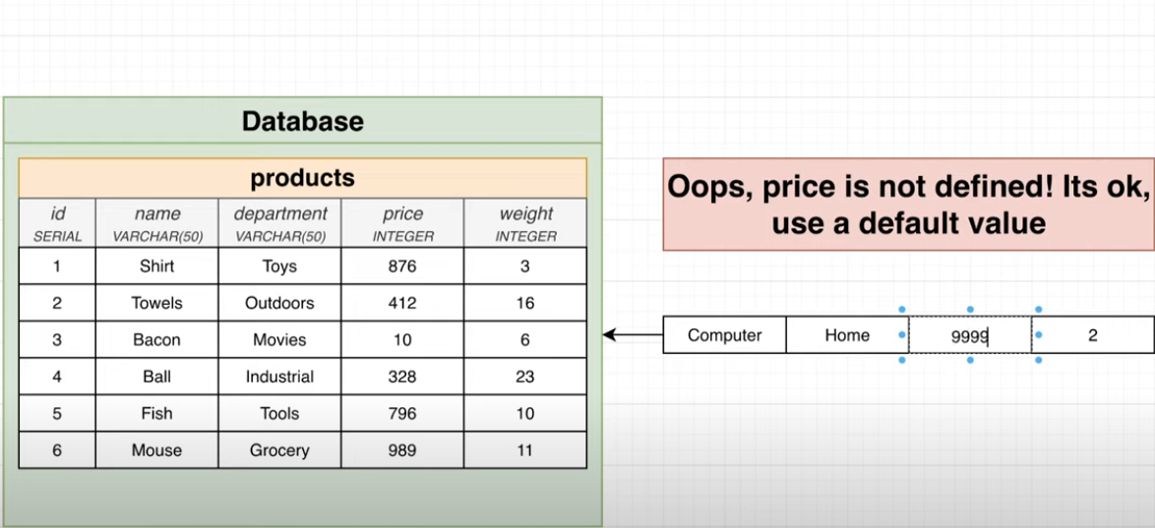  
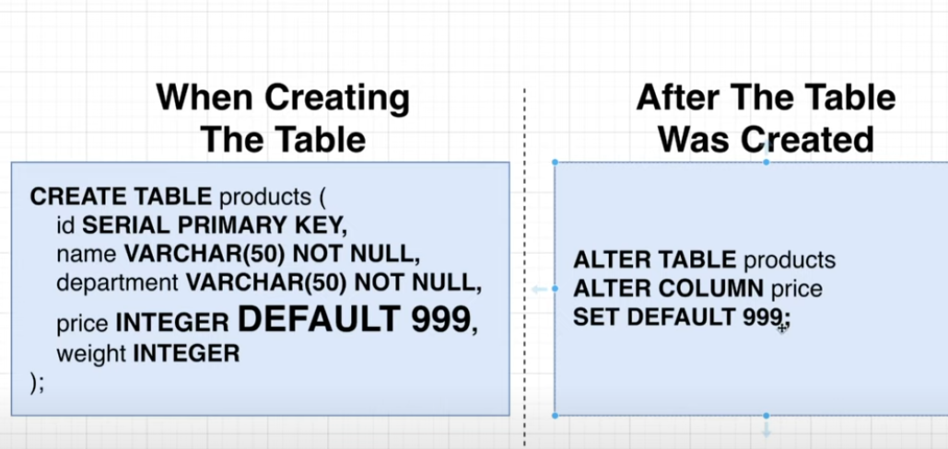  
  
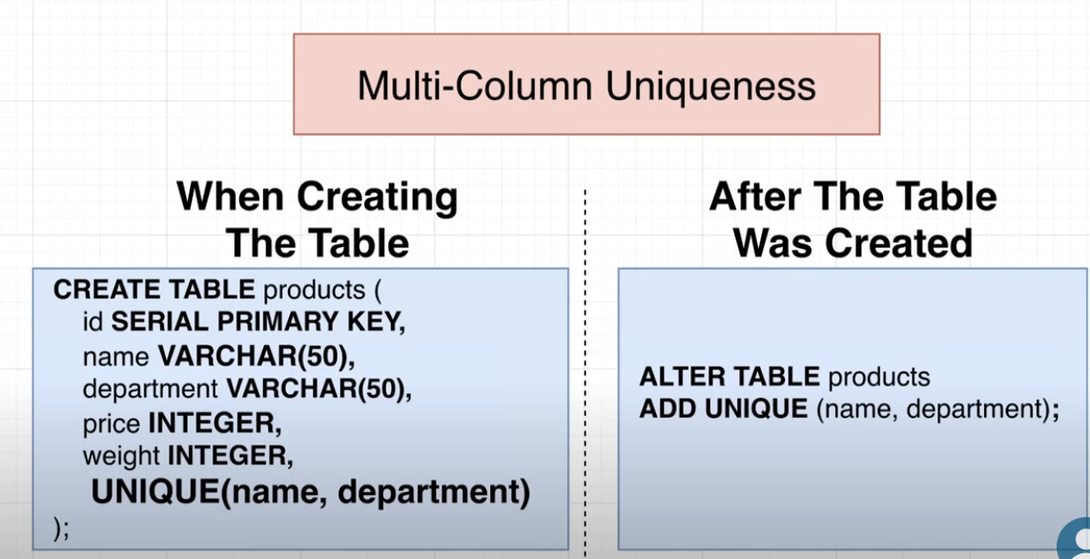  
  
=>Here we can define the check validation so while entering the value only it will check, value is greater or less from something.

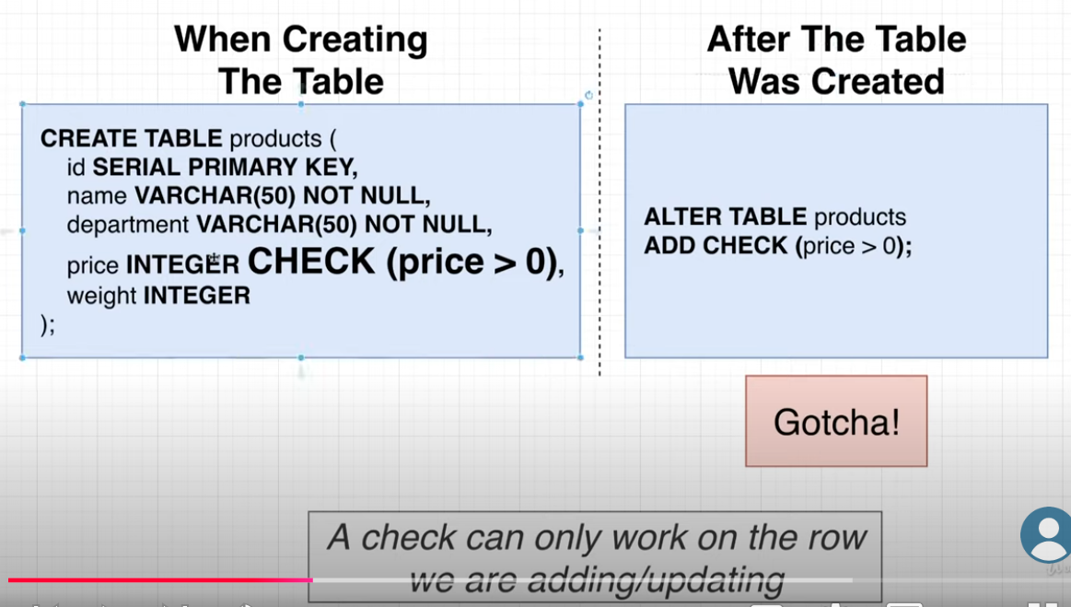  
=> But id enteries aleady entered in this case we can’t apply the CHECK().  
  
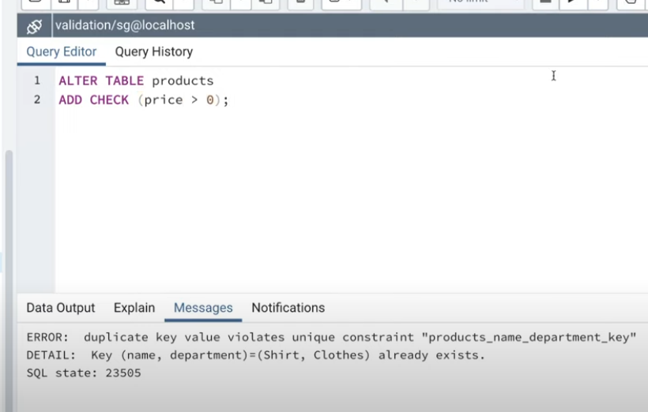  
=>Even we try to insert the record after applying CHECK() we can’t do this:  
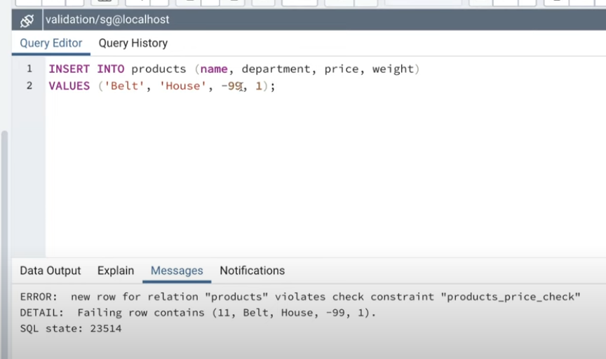   
Q:  
  
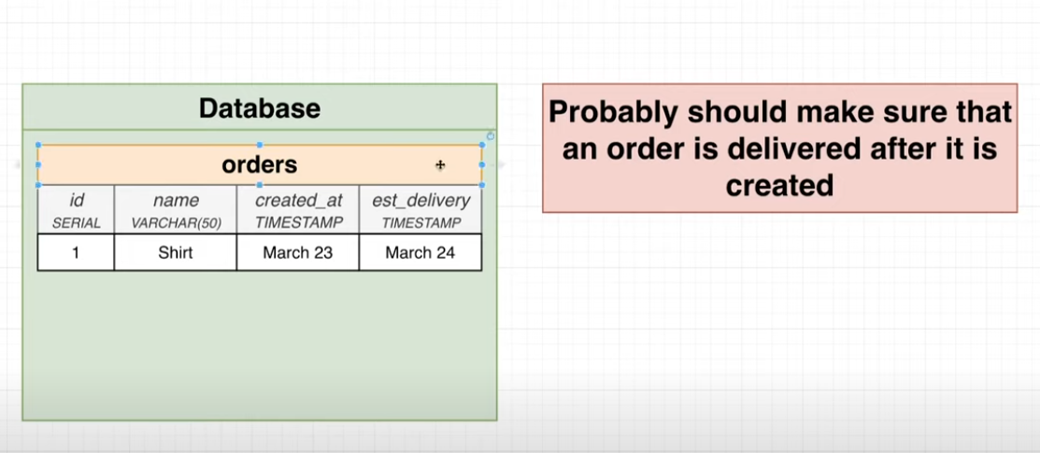  
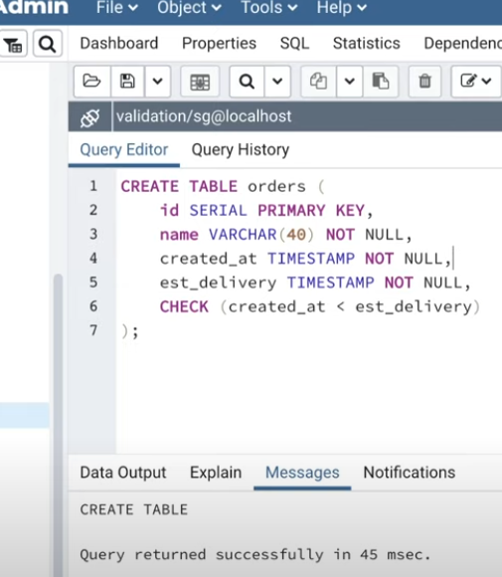  
=> Here we got the error because we are giving estimated delivery date early before order which canot possible in real world:  
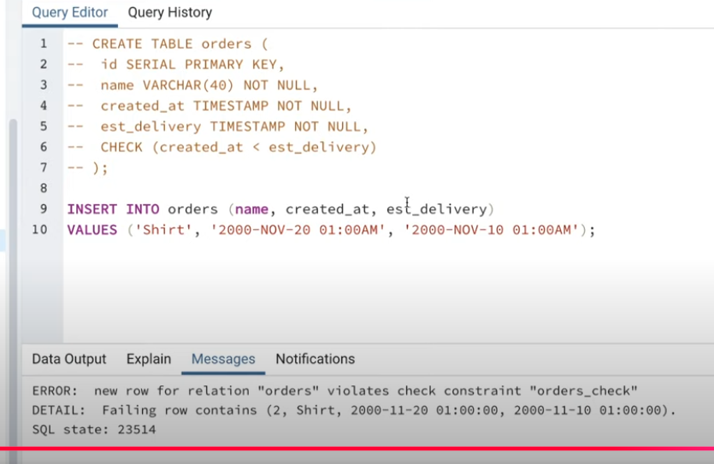  
 **=> ADDING VALIDATION AT WEB SERVER LEVEL:  
at web server level python library and build in function can handle but for more reliable DB we should seprate the validation beetwin WEB SERVER and DB:**  
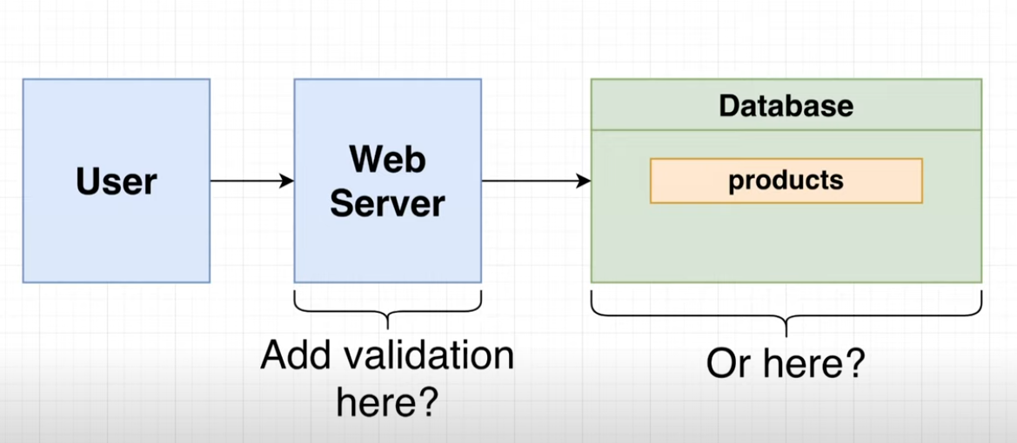 When to go for web server or when for Database level validation, when you have to go for complex validation at a movement like trading share should I buy or not than we can go for web server validation.

### **SHEMA DESIGN FOR INSTAGRAM #####**  :

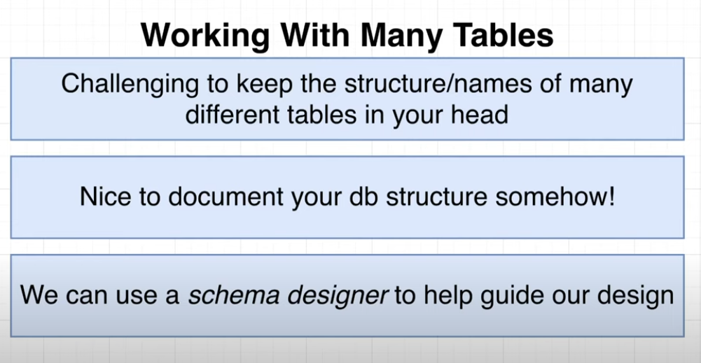  
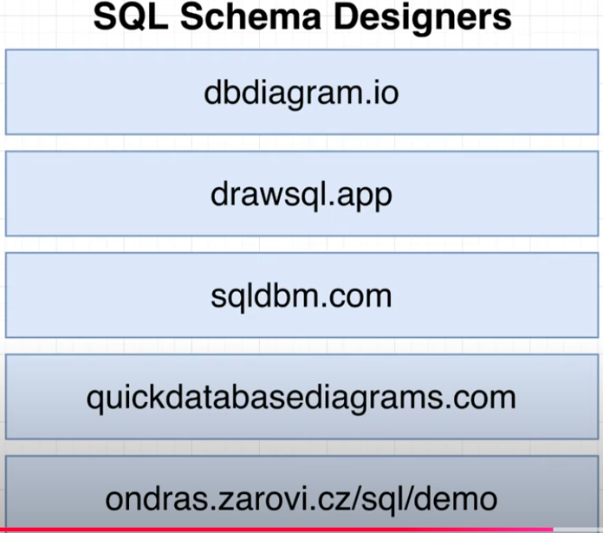  
=> using this tools basically we explaining the thoughts to other engineers about your project and schema and all.  
=> Any of the tool we can use it:

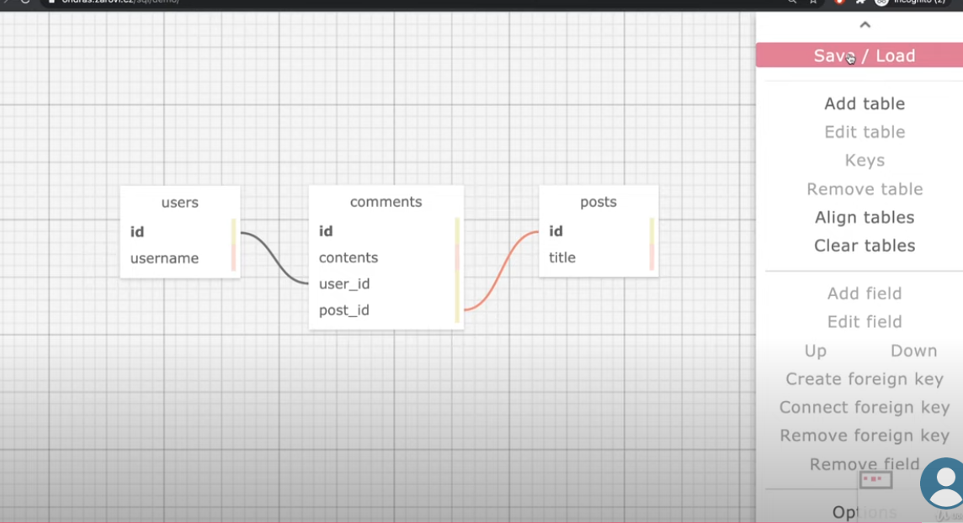  
=> Below will refrect on real world query base base 🡺  
=> This below way also we can connect to table each other using writing the code :  
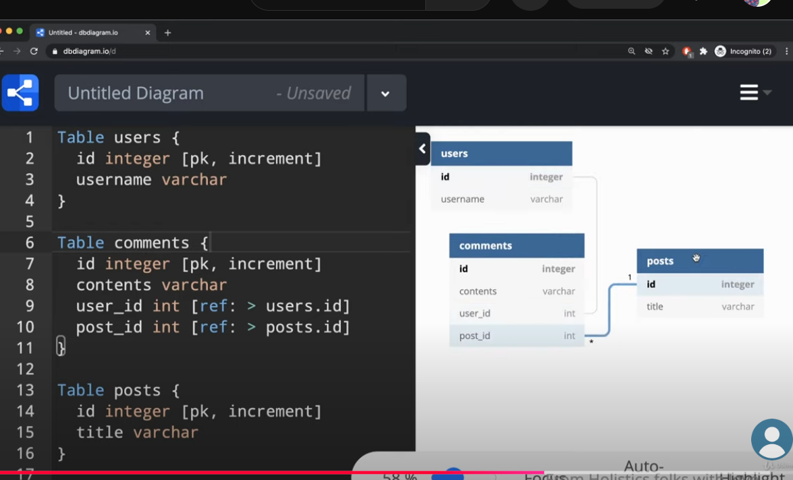  
=> **Let’s Design the Instagram schema:  
=> 1stly we have to understand the feature we have to build for this kind of application.  
=>For that check the below feature se needed for instagram schema design.  
  
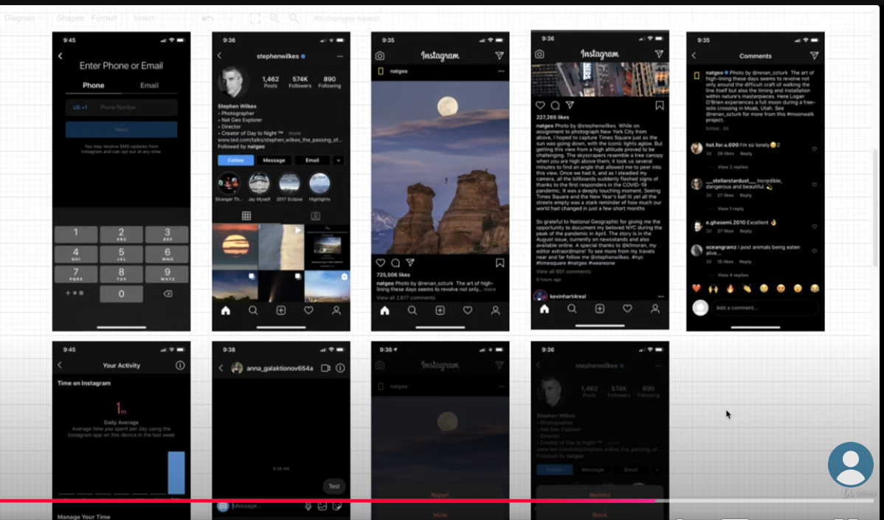  
 🡺 when ever we are trying to create a tables we need to think about the feature so that will be easy to create, so below we can think about the likes table.  
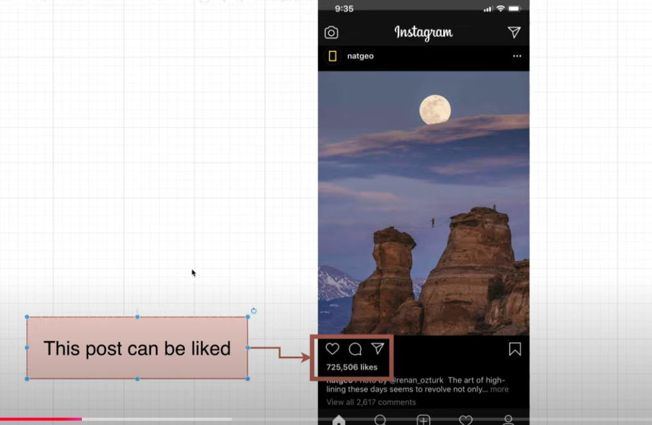  
=> always think about the feature eadge cases like what will be the rules and regulation.  
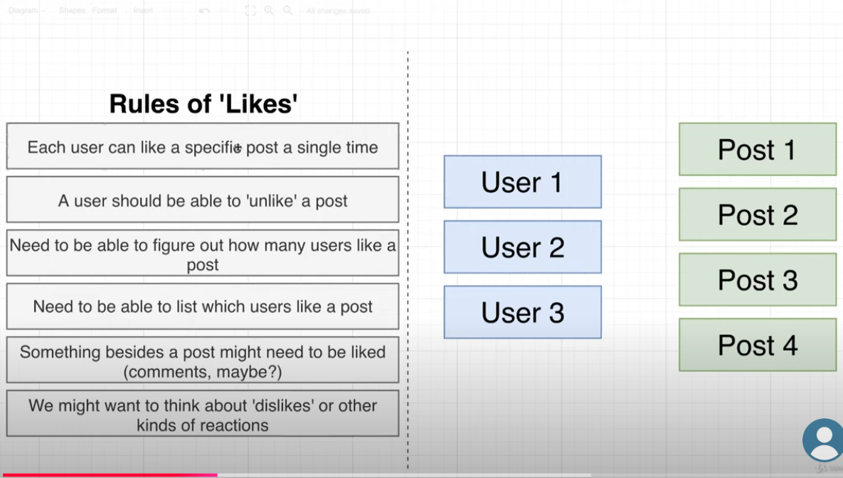  
  
🡺What should not do while creating the table:  
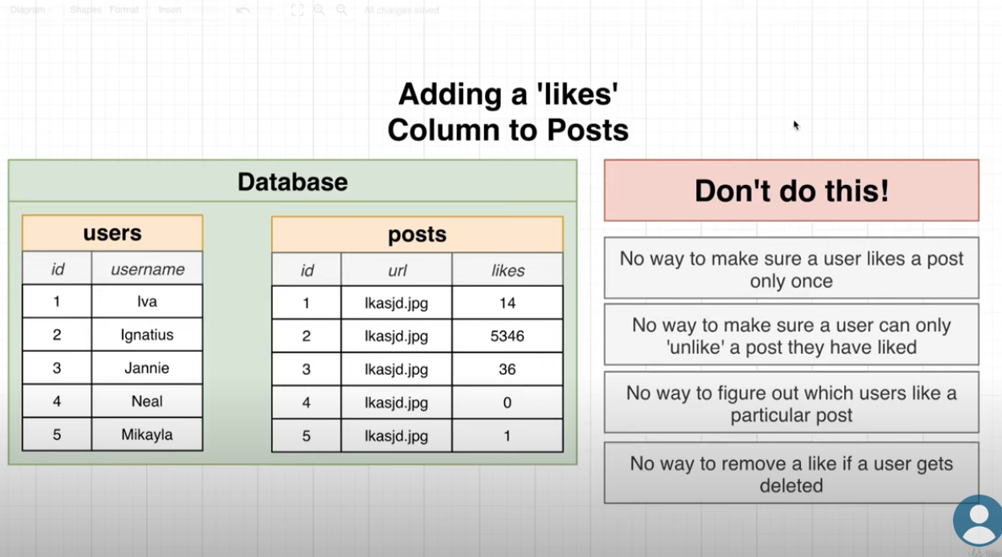   
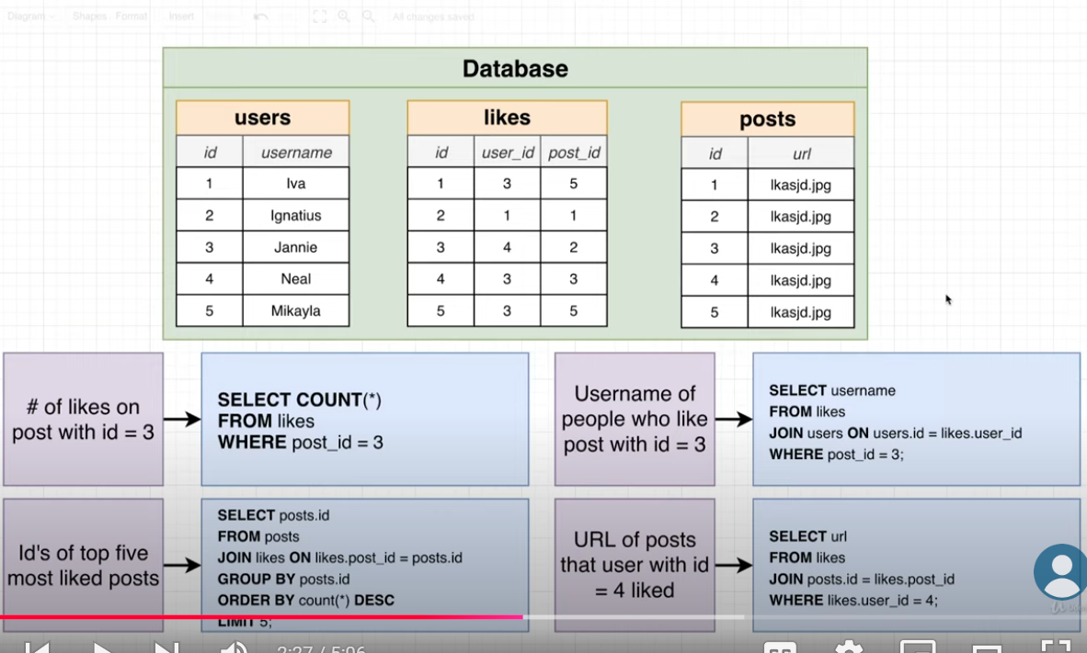  
=> same this way I can track the Bookmark post as well :  
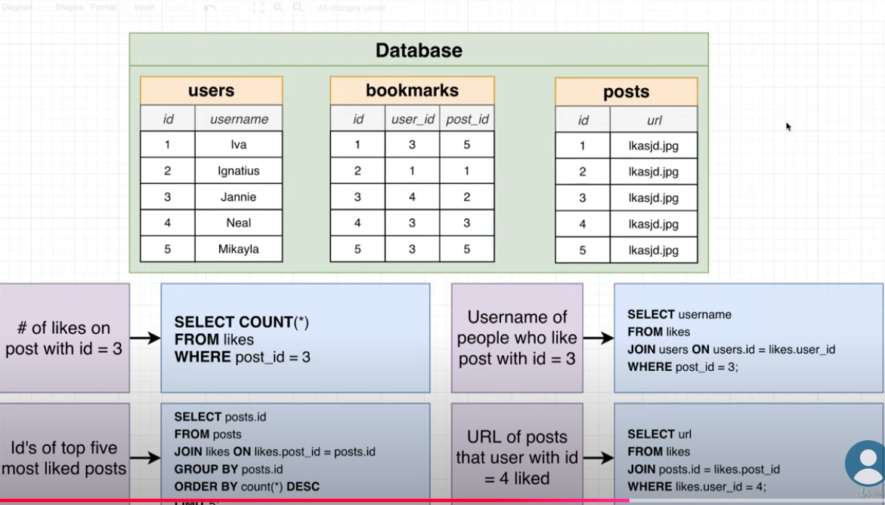  
=>Rather than this will going to use Polymorphim association with it.  
  
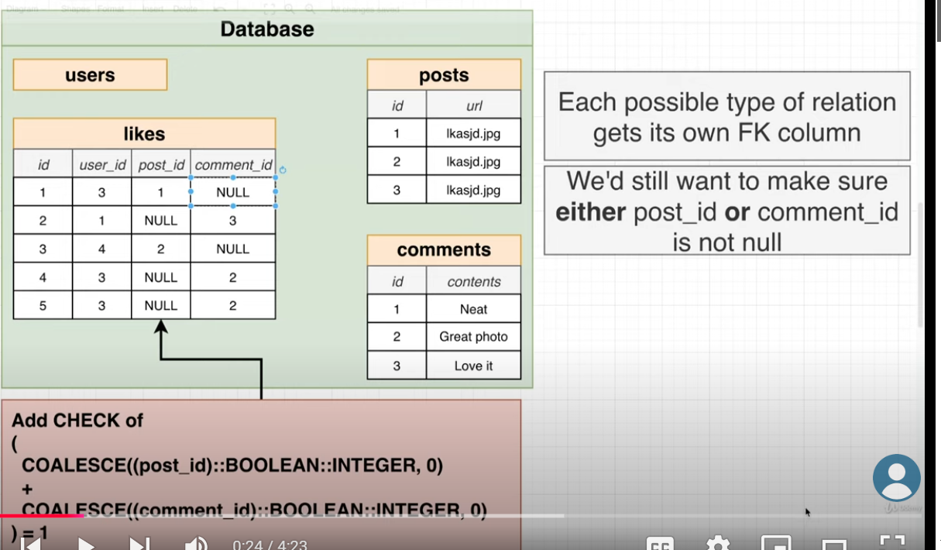  
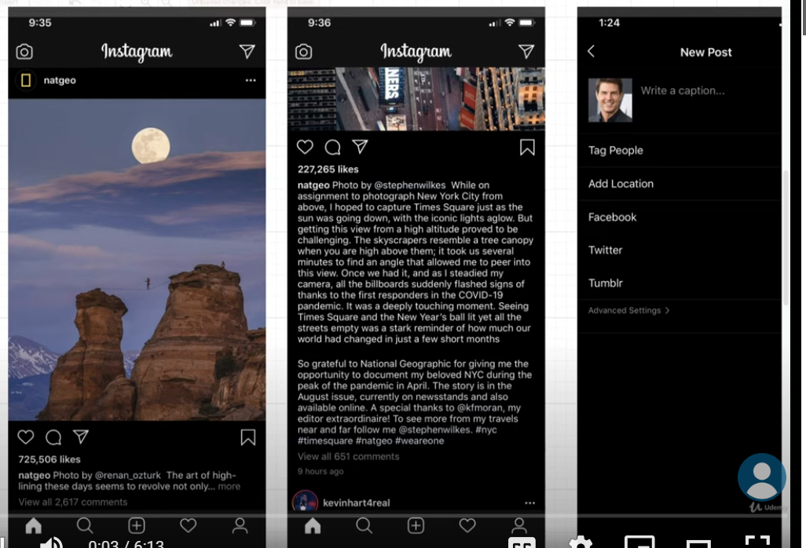**

**=> now we have to recheck the remaining feature instagram have to build it:  
ex: while new post location, people tagging, description, upload time, like remaining field yet to add :  
Note: For location storage we need Latitute and logitite so that we can store the exact location of the user.  
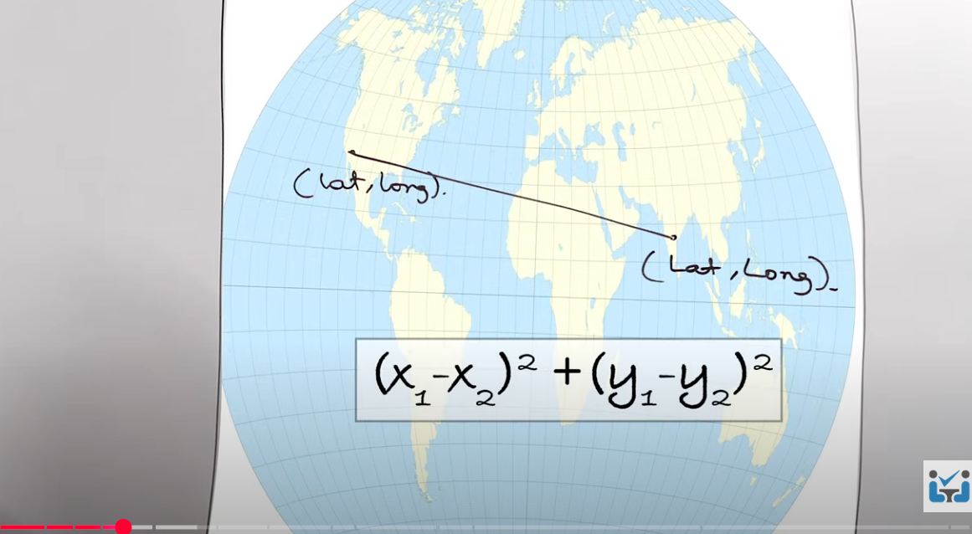  
=>assume again we divide this location to small squre part and will divide till we donot ge  
 the exact location.  
  
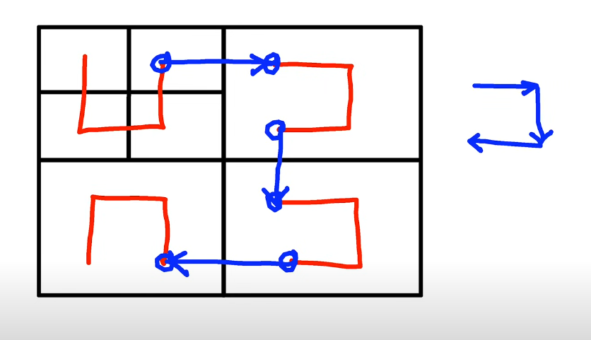  
Here in following uimage red arrow is for level2 connecter and blue arrows for level 1 connecter so that we can deliver the item very fast way.  
  
🡺 here weare using lat and lng to store the exact location and it will more accurate to 6 digits :  
  
  
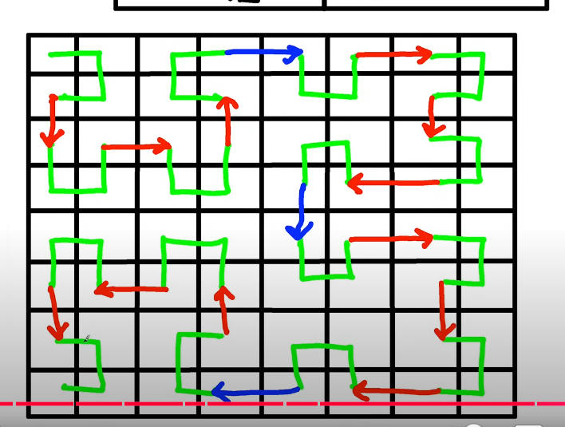  
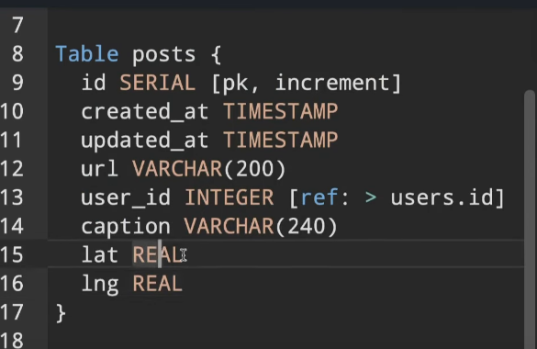**

**Note=> For tagging the people in post will create a tag table which will be in relationship with the posts table with post_id foreign key .**